**Compensation and Pension Record Interchange (CAPRI)**

**System Administration and Technical Guide**



September 2019

Department of Veterans Affairs

Office of Information and Technology

Revision History

|  |  |  |  |
| --- | --- | --- | --- |
| Date | Version | Description | Author |
| 08/05/2019 | 1.13 | Page 34, Appendix A - CAPRI Remote Procedure Calls for MUMPS, added DVBA CAPRI GET EDIPI2 Remote Procedure Call  Global, revised date on Title page and footers to “September” | C. Bernier |
| 04/2019 | 1.12 | Initial draft for Patch 212 | C. Bernier |
| 03/29/2019 | 1.11 | Page 20, Section 12.1, Added CAPRI Remote Procedure Calls Logger section | C. Bernier |
| 02/19/19 | 1.10 | Page 34, under Appendix A, added a new Remote Procedure Call: DVBA CAPRI GET EDIPI  Page 10, under 6.1 CAPRI GUI Client Software, revised 193.11 to 209 | C. Bernier |
| 05/24/18 | 1.9 | Updated sections 2.2.2.1. and 2.2.3. The JLV tab replaced the VistAWeb tab in GUI version DVBA*2.7*193.12, so references to VistAWeb were removed.  Updated section 2.2.1.1. Replaced reference to VistAWeb with JLV.  Replace Remedy with ServiceNow  DoD Tab has been disabled, and all references to DoD have been removed from the document.  Removed DataFlow Diagram from Section 3.  Added description for Joint Legacy Viewer (JLV) function (Section 2.2.3).  Section 8.2, updated last paragraph with revisions from 1st Review.  Updated formatting for Appendix A.  Updated Dates to May on title page and in footers. | C. Bernier |
| 4/16/2018 | 1.8 | URL to include descriptions for all values. Updated Appendix A, RPC parameter DVBAB GET | April Sessler |
| 09/30/15 | 1.7 | Updated Appendix A | Kristina DeLaCruz |
| 3/05/2015 | 1.6 | Updated various sections based on stakeholder feedback. | Gina Johnson |
| 2/25/2015 | 1.5 | Updated Appendix A | Randy Wipert / Jan Long |
| 12/4/2014 | 1.4 | Updated section 7.8 with a new screen shot | Bob Kaiser |
| 9/9/2014 | 1.3 | Updated section 15.2 to only contain VDL link to CAPRI | Kristina DeLaCruz |
| 4/9/2014 | 1.2 | Updated CAPRI Distribution File listing | Jan Long |
| 3/25/2013 | 1.1 | Updated sections 5 and 7.4 with changing the CLAIMS server FQDN from CLAIMS.FORUM.VA.GOV “to” CLAIMS.MED.VA.GOV as indicated by Michael Shickle 03/25/2013 | Gina Johnson |
| 7/10/2012 | 1.0 | Initial Publication | Eileen Fairbrother / Mike Jenkins / Donna Sandusky / George Kocis / Susan Koch |

Preface

Purpose of the System Administration and Technical Guide

The System Administration and Technical Guide document describes the handling, functionality, and architecture of the CAPRI product. The guide includes detailed information about the technical architecture and components associated with CAPRI.

Reference Numbering System

This document uses a numbering system to organize its topics into sections and show the reader how these topics relate to each other. For example, section 1.3 means this is the main topic for the third section of Chapter 1. If there were two subsections to this topic, they would be numbered 1.3.1 and 1.3.2. A section numbered 2.3.5.4.7 would be the seventh subsection of the fourth subsection of the fifth subsection of the third topic of Chapter 2. This numbering system tool allows the reader to more easily follow the logic of sections that contain several subsections.

Table of Contents

1. Introduction 1

1.1 Acronyms 1

1.2 Reference Materials 2

1.3 CAPRI Technical Support 3

2. Agency Partners 3

2.1 External Clients 3

2.2 Internal Clients 3

2.2.1. Veterans Health Administration 3

2.2.1.1. VHA Data Portal 3

2.2.2. Veterans Benefits Administration 3

2.2.2.1. Veteran Service Organization (VSO) 8

2.2.3. Joint Legacy Viewer 8

2.2.4. National Cemetery Administration 8

2.2.5. VA Office of Inspector General 8

3. Systems Relationship 8

3.1 Database Integration Agreements (DBIAs) 8

3.1.1. Custodial Agreements 8

3.1.2. Subscriber Agreements 9

4. Account Management 9

4.1 Establishing CAPRI Account 9

5. Installing CAPRI 9

6. CAPRI Distribution Files 10

6.1 CAPRI GUI Client Software 10

7. Logging onto CAPRI 11

7.1 Desktop Icon Shortcuts Setup 11

7.2 Non-CAPRI Remote Users 12

7.3 Regional Office CAPRI Remote Users 13

7.4 CAPRI Remote Users 15

7.5 VistA Terminal 16

7.6 Terminal Server Users 16

7.7 CAPRI News 17

7.8 CAPRI Alerts 17

7.9 Audit Kept 18

8. CAPRI Application Maintenance 18

8.1 CAPRI Application Software Maintenance 18

8.2 C&P Worksheet Template Maintenance 19

9. Applications Development Tools and Usage 20

10. Code Repository Tool (Version Control) 20

11. CAPRI Source Files for Delphi 2006 20

12. Remote Procedure Calls 20

12.1 CAPRI Remote Procedure Calls Logger 20

12.2 CAPRI Remote Procedure Calls (RPCs) for MUMPS 20

13. FileMan 23

13.1 Installation Procedures and Usage 23

13.1.1. Environmental Setup 23

13.1.2. Installation Guide 23

13.1.3. Getting Started 23

13.1.4. Advanced User 24

13.1.5. Programmer Manual 24

13.1.6. Technical Manual 24

13.1.7. Package-wide Variables 24

13.1.7.1. Key Variables 24

13.1.7.2. How to Generate Online Documentation 25

13.1.7.3. XIndex 25

14. Archiving, Purging, and Frequency 25

15. Security 26

15.1 Security Management 26

15.2 General Security 26

15.2.1. Remote Systems 26

15.2.2. Contingency Planning 26

15.2.3. Interfacing 26

15.2.4. Electronic Signatures 26

15.2.5. Security Keys 26

16. CAPRI Troubleshooting and Error Information 27

16.1 CAPRI Not Installed in VistA 27

16.2 CAPRI GUI Option Not Assigned to User in VistA 27

16.3 VistA Server Down 28

16.4 VistA Limits Ability to See Patient Records 28

16.5 Network Problems 28

16.6 Institution File in VistA has Been Locally Modified 29

16.7 Too Many Invalid Attempts at Access Code / Verify Code 29

16.8 Multiple Sign-Ons 29

16.9 General Error Message 30

Appendix A - CAPRI Remote Procedure Calls for MUMPS 31

Table of Figures

Figure 1 VBA’s Region 5 Business Line perspective Network map of CIOs 6

Figure 2 Test Claims Properties 10

Figure 3 Connect To Window 12

Figure 4 Connect To Window Selection 12

Figure 5 VistA Sign-on 13

Figure 6 VistA Sign-on Enter Access/Verify 13

Figure 7 VistA Sign-on – Change Access/Verify code 14

Figure 8 Change Verify Code 14

Figure 9 CAPRI Remote Site Selection Screen 15

Figure 10 Patient Selector Screen 15

Figure 11 Test Claims Properties 16

Figure 12 CAPRI News 17

Figure 13 CAPRI Alerts 18

Figure 14 Display the RPC listing to your screen 22

Figure 15 CAPRI Not Installed in VistA Error Message 27

Figure 16 CAPRI GUI Option Not Assigned to User in VistA 27

Figure 17 VistA Server Down Error Message 28

Figure 18 VistA Limits Ability to See Patient Records 28

Figure 19 Could not connect to Remote Server Error Message 29

Figure 20 Incomplete or Incorrect Regional Office 29

Figure 21 Device locked due to multiple sign-on message 29

Figure 22 Multiple Sign-ons error Message 30

Figure 23 General Error Message 30

# Introduction

The Compensation and Pension Record Interchange (CAPRI) project is an information technology initiative to improve service to disabled veterans by promoting efficient communication between the Veterans Health Administration (VHA) and Veterans Benefits Administration (VBA). Online access to medical data enhances the timeliness of the benefits determination. Previous attempts to automate this process were hindered by the "roll and scroll" nature of the VHA computer interface of the Automated Medical Information Exchange (AMIE) II. The CAPRI software acts as a bridge between the VBA and VHA information systems. It offers VBA Rating Veteran Service Representatives and Decision Review Officers help in building the rating decision documentation through online access to medical data. It also offers VHA Compensation and Pension (C&P) staff an easy, standardized way of recording C&P Examination reports.

CAPRI provides VBA employees with a standardized, user-friendly method to rapidly access veterans' electronic medical records throughout the Department of Veterans Affairs (VA). CAPRI delivers leading edge "point and click" technology to the users' desktops. In addition, the learning curve for CAPRI is significantly less than that for character-based systems. CAPRI builds upon existing VHA information security approaches. In addition to using established mechanisms to ensure only authorized access to medical data, CAPRI adds a level of security by allowing VBA users to read but not alter electronic medical record information. CAPRI also provides innovative improvements for medical centers by integrating highly detailed (C&P) Rating examination results into the veterans' medical records. Previously, these reports were not retained online in medical center computer systems but were archived onto paper. This procedure precluded the sharing of clinically useful data.

Initially developed specifically for VBA, the utility of CAPRI has been expanded to other user groups that include VHA, Office of the Medical Inspector, Office of Information (OI), Research, and Veteran Service Officers. Recently, most of the newest features of CAPRI are specifically targeted at adding features to be used by VHA C&P providers and staff.

***Note:***  *This document has extensive use of URLs to enable the user access to the best, current, and specific information available.*

## Acronyms

| Term | Definition |
| --- | --- |
| A&A | Advisory & Assistance |
| AHLTA | Armed Forces Health Longitudinal Technology Application (formerly CHCS II, US DoD military health system) |
| AMIE | Automated Medical Information Exchange |
| AWIV | Advanced Web Image Viewer |
| C&P | Compensation and Pension |
| CAPRI | Compensation and Pension Record Interchange |
| CPRS | Computerized Patient Record System |
| CPWM | Compensation and Pension Worksheet Module |
| DBQ | Disability Benefits Questionnaire |
| DoD | Department of Defense |
| DVBA | The pre-fix for AUTOMATED MED INFO EXCHANGE (namespace). VBA's interface into VistA. |
| EHR | Electronic Health Record |
| FHIE | Federal Health Information Exchange |
| GUI | Graphical User Interface |
| HTML | HyperText Markup Language |
| IDE | Interactive Development Environment |
| IAs | Integration Agreements |
| IRM | Information Resources Management |
| IS | **Information Systems** |
| IT | **Information Technology** |
| MAS | Medical Administration Service |
| MUMPS / M | [Massachusetts General Hospital](http://en.wikipedia.org/wiki/Massachusetts_General_Hospital) Utility Multi-Programming System |
| NCIO | Network Chief Information Officer |
| NPM | National Patch Module |
| OI | Office of Information |
| OIT | Office of Information Technology |
| RDV | Remote Data View |
| RO | Regional Office |
| RPC | Remote Procedure Call |
| TIU | Text Integration Utilities |
| URL | Universal Resource Locator (Internet Shortcut – file name extension) |
| VA | Department of Veterans Affairs |
| VAMC | VA Medical Center |
| VBA | Veterans Benefits Administration |
| VDL | VA (Software) Document Library |
| VHA | Veterans Health Administration |
| VISN | Veterans Integrated Service Network |
| VistA | Veterans Health Information Systems and Technology Architecture |

## Reference Materials

This section contains all referenced materials related to this document.

* <http://vbaw.vba.va.gov/bl/21/Systems/capamie.htm>
* <http://vaww.vhadataportal.med.va.gov/>
* <http://www.hardhats.org/index.html>
* <http://www.va.gov/oig/52/reports/2007/VAOIG-05-01143-71.pdf>
* <http://www.va.gov/oig/54/reports/VAOIG-08-03299-217.pdf>
* <http://www.va.gov/TRM/ToolPage.asp?tid=39>
* <http://www.va.gov/vdl/>
* <http://www.va.gov/vdl/application.asp?appid=133>
* <http://www.va.gov/vdl/application.asp?appid=31>
* <http://www.va.gov/vdl/application.asp?appid=5>
* <http://www.va.gov/vdl/application.asp?appid=163>

***DISCLAIMER:*** *The appearance of external hyperlink references in the manual does not constitute endorsement by the VA of this Web site or the information, products, or services contained therein. The VA does not exercise any editorial control over the information you may find at these locations. Such links are provided and consistent with the stated purpose of the VA.*

## CAPRI Technical Support

The following link provides CAPRI specific information regarding obtaining CAPRI access, CAPRI Training, Advanced Web Image Viewer (AWIV) Desk Reference, CAPRI/Virtual VA interactions, and other useful information at: <http://vbaw.vba.va.gov/bl/21/DEMO/capri.htm>. This link applies to VBA users.

User support questions should be addressed to local IT support staff, Information Resources Management (IRM), or one of the National Service Desks. A ServiceNow ticket may be submitted for CAPRI related issues to the National Service Desk at 1-855-673-4357.

# Agency Partners

## External Clients

Non-VA users include external reviewers and researchers obtaining information from various VA administrations for their specific authorized purposes.

## Internal Clients

CAPRI is a VHA developed application. The other two administrations within the VA, VBA and the National Cemetery Administration, use CAPRI directly and/or indirectly.

### Veterans Health Administration

The following link (URL) provides a complete list of VHA Medical Centers, Outpatient Clinics, Community Based Outpatient Clinics, Vet Centers, and Veterans Integrated Service Network (VISN) locations where the VHA utilizes the CAPRI system.

<https://www.benefits.va.gov/benefits/>

The level of access granted to users will depend on job function, need to know, and the level of security placed on certain sensitive patient records.

#### VHA Data Portal

This VHA program coordinates access to many of VHA’s health information resources that include national databases, EHRs, extracted datasets, and medical record data found in CPRS through CAPRI and Joint Legacy Viewer (JLV).

### Veterans Benefits Administration

The following table lists the VBA regional office (RO) locations with each of their VBA system name.

***Note:*** *VBA IT continues to use the VA Office of Information Technology (OIT) naming convention method prior to its reorganization. This naming convention is organizational versus geographical in nature. This table reflects that as all VBA IT locations fall under Region 5. VHA IT currently uses the VA OIT current geographical naming convention. Additionally, VBA from a Business Line perspective doesn’t use Region 5 but breaks Region 5 down into three separate NCIOs. (See map following this table).*

| **VBA Region 5** | |
| --- | --- |
| **REGIONAL OFFICE LOCATION** | **SYSTEM_NAME** |
| **ST. PETERSBURG REGION** | |
| Atlanta, GA | REGION 5 > VBA > St Petersburg Region > VARO Atlanta > LAN |
| Baltimore, MD | REGION 5 > VBA > St Petersburg Region > VARO Baltimore > LAN |
| Columbia, SC | REGION 5 > VBA > St Petersburg Region > VARO Columbia > LAN |
| Huntington, WV | REGION 5 > VBA > St Petersburg Region > VARO Huntington > LAN |
| Jackson, MS | REGION 5 > VBA > St Petersburg Region > VARO Jackson > LAN |
| Little Rock, AR | REGION 5 > VBA > St Petersburg Region > VARO Little Rock > LAN |
| Louisville, KY | REGION 5 > VBA > St Petersburg Region > VARO Louisville > LAN |
| Montgomery, AL | REGION 5 > VBA > St Petersburg Region > VARO Montgomery > LAN |
| Nashville, TN | REGION 5 > VBA > St Petersburg Region > VARO Nashville > LAN |
| New Orleans, LA | REGION 5 > VBA > St Petersburg Region > VARO New Orleans > LAN |
| Newark, NJ | REGION 5 > VBA > St Petersburg Region > VARO Newark > LAN |
| Roanoke, VA | REGION 5 > VBA > St Petersburg Region > VARO Roanoke > LAN |
| St. Louis, MO | REGION 5 > VBA > St Petersburg Region > VARO St. Louis > LAN |
| St. Louis RMC, MO | REGION 5 > VBA > St Petersburg Region > VARO St. Louis RMC > LAN |
| St. Petersburg, FL | REGION 5 > VBA > St Petersburg Region > VARO St. Petersburg > LAN |
| Washington, DC | REGION 5 > VBA > St Petersburg Region > VARO Washington > LAN |
| Winston-Salem, NC | REGION 5 > VBA > St Petersburg Region > VARO Winston-Salem > LAN |
| **St. Paul Region** | |
| Boston, MA | REGION 5 > VBA > St Paul Region > VARO Boston > LAN |
| Buffalo, NY | REGION 5 > VBA > St Paul Region > VARO Buffalo > LAN |
| Chicago, IL | REGION 5 > VBA > St Paul Region > VARO Chicago > LAN |
| Cleveland, OH | REGION 5 > VBA > St Paul Region > VARO Cleveland > LAN |
| Des Moines, IA | REGION 5 > VBA > St Paul Region > VARO Des Moines > LAN |
| Detroit, MI | REGION 5 > VBA > St Paul Region > VARO Detroit > LAN |
| Fargo, ND | REGION 5 > VBA > St Paul Region > VARO Fargo > LAN |
| Hartford, CT | REGION 5 > VBA > St Paul Region > VARO Hartford > LAN |
| Indianapolis, IN | REGION 5 > VBA > St Paul Region > VARO Indianapolis > LAN |
| Lincoln, NE | REGION 5 > VBA > St Paul Region > VARO Lincoln > LAN |
| Manchester, NH | REGION 5 > VBA > St Paul Region > VARO Manchester > LAN |
| Milwaukee, WI | REGION 5 > VBA > St Paul Region > VARO Milwaukee > LAN |
| New York, NY | REGION 5 > VBA > St Paul Region > VARO New York > LAN |
| Philadelphia, PA | REGION 5 > VBA > St Paul Region > VARO Philadelphia > LAN |
| Pittsburgh, PA | REGION 5 > VBA > St Paul Region > VARO Pittsburgh > LAN |
| Providence, RI | REGION 5 > VBA > St Paul Region > VARO Providence > LAN |
| Sioux Falls, SD | REGION 5 > VBA > St Paul Region > VARO Sioux Falls > LAN |
| St. Paul, MN | REGION 5 > VBA > St Paul Region > VARO St. Paul > LAN |
| Togus, ME | REGION 5 > VBA > St Paul Region > VARO Togus > LAN |
| White River Jct, VT | REGION 5 > VBA > St Paul Region > VARO White River Jct. > LAN |
| Wichita, KS | REGION 5 > VBA > St Paul Region > VARO Wichita > LAN |
| Wilmington, DE | REGION 5 > VBA > St Paul Region > VARO Wilmington > LAN |
| **SAN DIEGO REGION** | |
| Albuquerque, NM | REGION 5 > VBA > San Diego Region > VARO Albuquerque > LAN |
| Anchorage, AK | REGION 5 > VBA > San Diego Region > VARO Anchorage > LAN |
| Boise, ID | REGION 5 > VBA > San Diego Region > VARO Boise > LAN |
| Denver, CO | REGION 5 > VBA > San Diego Region > VARO Denver > LAN |
| Cheyenne, WO | REGION 5 > VBA > San Diego Region > VARO Cheyenne > LAN |
| Fort Harrison, MT | REGION 5 > VBA > San Diego Region > VARO Fort Harrison > LAN |
| Honolulu, HI | REGION 5 > VBA > San Diego Region > VARO Honolulu > LAN |
| Houston, TX | REGION 5 > VBA > San Diego Region > VARO Houston > LAN |
| Los Angeles, CA | REGION 5 > VBA > San Diego Region > VARO Los Angeles > LAN |
| Manila, PI | REGION 5 > VBA > San Diego Region > VARO Manila > LAN |
| Muskogee, OK | REGION 5 > VBA > San Diego Region > VARO Muskogee > LAN |
| Oakland, CA | REGION 5 > VBA > San Diego Region > VARO Oakland > LAN |
| Phoenix, AZ | REGION 5 > VBA > San Diego Region > VARO Phoenix > LAN |
| Portland, OR | REGION 5 > VBA > San Diego Region > VARO Portland > LAN |
| Reno, NV | REGION 5 > VBA > San Diego Region > VARO Reno > LAN |
| Salt Lake City, UT | REGION 5 > VBA > San Diego Region > VARO Salt Lake City > LAN |
| San Diego, CA | REGION 5 > VBA > San Diego Region > VARO San Diego > LAN |
| San Juan, PR | REGION 5 > VBA > San Diego Region > VARO San Juan > LAN |
| Seattle, WA | REGION 5 > VBA > San Diego Region > VARO Seattle > LAN |
| Waco, TX | REGION 5 > VBA > San Diego Region > VARO Waco > LAN |

This is the VBA’s Region 5 Business Line perspective Network map of CIOs:

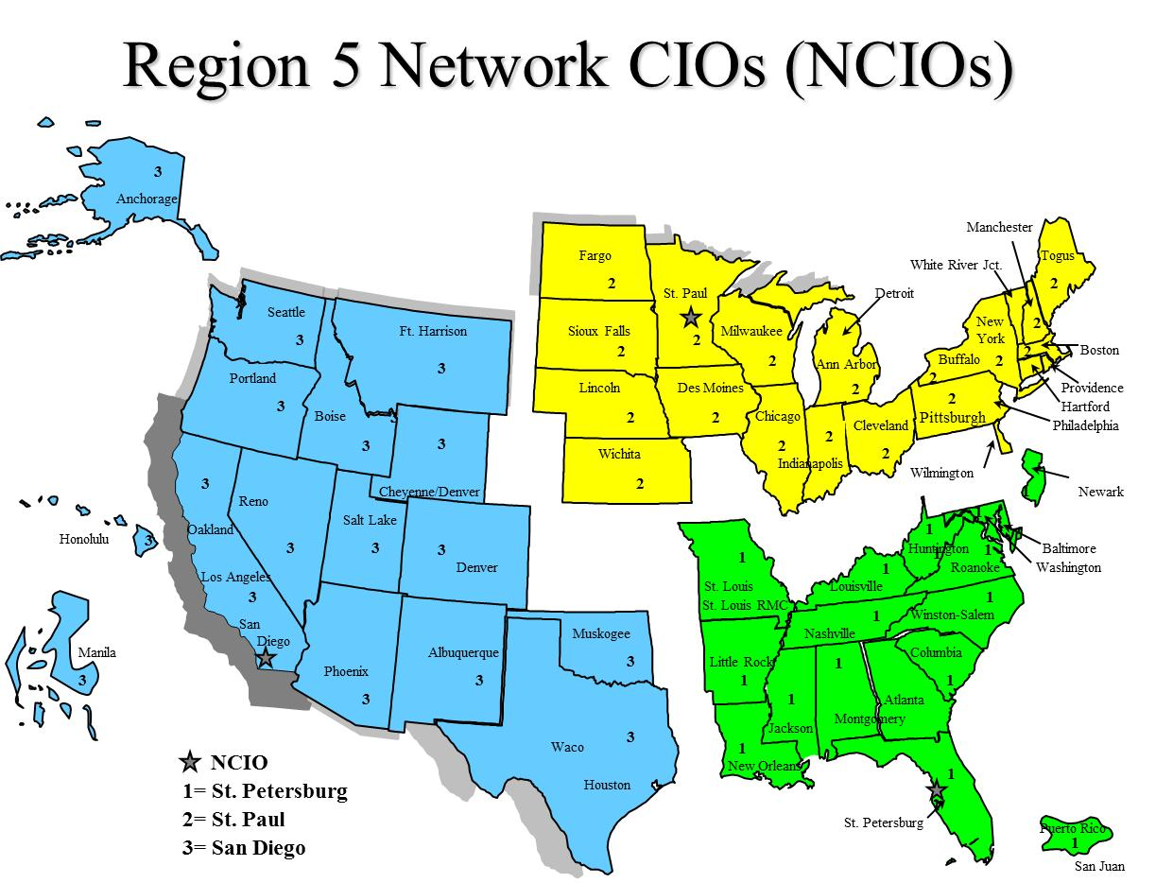

Figure 1 VBA’s Region 5 Business Line perspective Network map of CIOs

#### Veteran Service Organization (VSO)

All VSO offices are co-located with VBA regional offices as shown in the table of the previous Section 2.2.2. The VSO has authorized CAPRI read-only permissions for specific claimant’s EHR. This access allows the VSO to help a veteran who is preparing a VA benefit claim.

CAPRI offers VSO users:

* A national user account option with a single access/verify code, from which authorized users can view a Veteran’s entire VA health record from any site where the Veteran has been seen
* Customizable reports and health summaries
* C&P exam requests and results
* A search feature that enables users to search progress notes and discharge summaries for text
* Access to current and past AMIE C&P claims activity
* Access to Joint Legacy Viewer (JLV) for integrated read-only view of health data

### Joint Legacy Viewer

The JLV provides an integrated read-only view of health data from all VA and VA community partner sites where the Veteran or Service member has received care.

### National Cemetery Administration

The National Cemetery Administration does not directly use the CAPRI application, but receives its verified veteran information through VBA. VBA uses CAPRI to acquire this veteran information.

### VA Office of Inspector General

The VA Office of Inspector General performs audits and conducts research for reports when directed using CAPRI accessed data.

# Systems Relationship

## Database Integration Agreements (DBIAs)

There is a large amount of data as well as continual changes within the DBIAs. Therefore, it is recommended to follow these steps to obtain the most current and valid DBIAs for the CAPRI/AMIE package.

### Custodial Agreements

A list of CAPRI/AMIE current custodial Integration Agreements (IAs) can be created by FORUM users with DBA Menu access by following these steps:

1. Log on to FORUM

2. DBA Menu

3. Integration Control Registrations Menu

4. Custodial Package Menu

5. Active ICRs by Custodial Package Option

6. Select Package Name: AMIE

### Subscriber Agreements

A list of CAPRI/AMIE current subscriber IAs can be created by FORUM users with DBA Menu access by following these steps:

1. Log on to FORUM

2. DBA Menu

3. Integration Control Registrations Menu

4. Subscriber Package Menu

5. Print Active by Subscriber Package Option

6. Start with subscribing package: AUTOMATED MED INFO A

7. Go to subscribing package: AUTOMATED MED INFO Z

# Account Management

## Establishing CAPRI Account

CAPRI access for local VHA medical center users is managed by the local IRM/ISO staff at the medical center, just like any other application (i.e. roll-and-scroll VistA, CPRS, BCMA, etc.). HIA only manages CAPRI users that authenticate/authorize through the CLAIMS system. To contact the HIA team send email to: [hia.vso@va.gov](mailto:hia.vso@va.gov)

Once you obtain access and depending on your role you will be able to create additional accounts using CAPRI tools. Refer to the latest version of the CAPRI GUI User Manual in the VA (Software) Document Library (VDL); see section “Edit Remote User Site Access” at the following URL:

<https://www.va.gov/vdl/application.asp?appid=133>

# Installing CAPRI

***Note:*** *It is important that all users at your site remain on the same version.*

The AMIE package must be installed and maintained at VistA sites with patient data that will be accessed through the CAPRI GUI application. Installation and configuration of the AMIE package is described in the AMIE Installation Guide, Technical Manual, and Release Notes found at: <http://www.va.gov/vdl/application.asp?appid=31>

The AMIE package is maintained through patches in the Department of Veterans Benefits Administration (DVBA) namespace, issued through the VistA National Patch Module (NPM).

For the VBA, the new version runs when the user starts the application from **Start/All Programs/VBAPPS/CAPRIREMOTE.** The user can make new Windows desktop shortcuts (see Section 7.1) after starting the new version.

For the VHA, the IRM department will install the CAPRI desktop icon. Please check with them on the specifics of starting CAPRI. Normally, the user should find the CAPRI shortcut in the same place the user would find the Computerized Patient Record System (CPRS).

**Local VistA Connection:** The CAPRI shortcut can be set to connect to a specific VistA system. CAPRI will accept the command line parameters **s=servername** and **p=portname**, just like CPRS.

**CAPRI REMOTE**: CAPRI Remote users access CAPRI through the Claims system, which runs on the VHA Forum hardware. The server for those users should be set to **CLAIMS.MED.VA.GOV**, port **9400**. For more details reference the latest version of the CAPRI GUI User Manual, see section “CAPRI Remote Functionality” at the following URL: <http://www.va.gov/vdl/application.asp?appid=133>

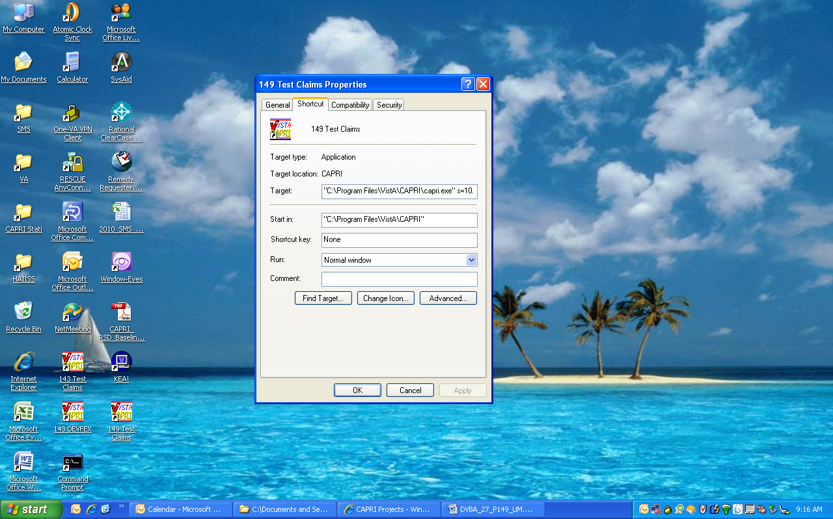

Figure 2 Test Claims Properties

# CAPRI Distribution Files

## CAPRI GUI Client Software

The CAPRI GUI client software is distributed as a zipped file from which the executable CAPRI.exe is extracted. Information on downloading the installation files for the CAPRI GUI software is included in the FORUM patch announcing a new version of CAPRI. The following is a sample of a FORUM patch section describing the availability of the installation files and other documents pertaining to the GUI distribution.

Release notes are normally provided with each release to provide a list of the updates included in the patch, because not all users have access to the patch description. The user manual is included if it is updated. The distribution of these documents is at the discretion of each installing facility. The updated documents are placed on the VDL site following patch release.

All files needed to install CAPRI Patch DVBA*2.7*212 can be downloaded from the standard “anonymous” software directory. The CAPRI GUI client software and documentation are available using FTP. The preferred method is to FTP the files from:

<ftp://download.vista.med.va.gov/> (Files will be in an anonymous.software directory)

This transmits the files from the first available FTP server. Sites may also elect to retrieve software directly from a specific server as follows:

        OI&T FIELD OFFICE       FTP ADDRESS                DIRECTORY

        -----------------       -----------                ---------

        Albany             [ftp.fo-albany.med.va.gov](ftp://ftp.fo-albany.med.va.gov)   [anonymous.software]

        Hines              [ftp.fo-hines.med.va.gov](ftp://ftp.fo-hines.med.va.gov)    [anonymous.software]

        Salt Lake City     [ftp.fo-slc.med.va.gov](ftp://ftp.fo-slc.med.va.gov)      [anonymous.software]

The following files will be available:

Required Distribution Files to Run the CAPRI Application

File Name Contents Retrieval format

--------- -------- ---------------

CAPRI GUI ZIP DVBA_27_P212_06.ZIP BINARY

Zip file contents:

- CAPRI.exe CAPRI v212 executable

- VACAPRIVVA.dll Virtual VA dynamically linked library

- CAPRI_Help.chm CAPRI On-line Help

- CAPRI.map CAPRI error map

- CAPRISession.rdox MicroFocus Reflection session

configuration

- CapriTerminalEmulators.ini

- ssh_config Secure Shell configuration

- Libeay32.dll VLER /DAS dynamically linked library

- Ssleay32.dll VLER /DAS dynamically linked library

- QPDF.exe Support PDF compression and Linearization

- QPDF13.dll Support PDF compression and Linearization

- LIBGCC_S_DW2-1.dll Support PDF compression and Linearization

- LIBSTDC++-6.dll Support PDF compression and Linearization

Optional Distribution Files that Contain Important User Info

DVBA_27_212_ISG.pdf GUI Installation Supplemental Guide

DVBA_27_212_RN.pdf Patch Release Notes BINARY

DVBA_27_212_UM.pdf Updated CAPRI User Manual BINARY

DVBA_27_212_Sys_Adm.pdf SAT GUIDE BINARY

***Note:*** *The VDL web site is usually updated within 1-3 days of the release date and will contain the “Release Notes” and if updated the “CAPRI GUI User Manual” as shown in the highlighted text above. The VDL’s URL is:* <http://www.va.gov/vdl/application.asp?appid=133>

# Logging onto CAPRI

The information is this section is a combination from several different sources but most of the information can be found in the latest version of the CAPRI GUI User Manual, see section “Logging On” at the following URL: <http://www.va.gov/vdl/application.asp?appid=133>

Please check this main source, the latest version of the CAPRI GUI User Manual, for any updated information that may not be found here.

## Desktop Icon Shortcuts Setup

***Note:*** *It is important that all users at your site remain on the same version. Additionally, there is no required fixed location for the CAPRI executable. The location is at the discretion of each installing facility. CAPRI is routinely installed in the Program Files/VistA/CAPRI directory of a user’s workstation. Many sites install the GUI on a network share drive and place a shortcut on the user’s workstations. Other sites install the GUI on a Citrix server for remote access.*

For the VBA, the new version runs when the user starts the application from **Start/All Programs/VBAPPS/CAPRIREMOTE.** It is recommended that for shortcuts, VBA users utilize this folder.

For the VHA, the IRM department will install the CAPRI desktop icon. Please check with them on the specifics of starting CAPRI. Normally, the user should find the CAPRI shortcut in the same place the user would find the CPRS.

**Local Vista Connection:** The CAPRI shortcut can be set to connect to a specific VistA system. CAPRI will accept the command line parameters **s=servername** and **p=portname**, just like CPRS. See the “Additional Information” section; subsection “Installation,” in the latest version of the CAPRI GUI User Manual, at the following URL: <http://www.va.gov/vdl/application.asp?appid=133>

## Non-CAPRI Remote Users

**Step 1** – The user starts by double-clicking the CAPRI icon.

**Step 2** – **OPTIONAL** – If the workstation has been configured with serverlist.exe by IRM, and if there is no server and port information in the CAPRI shortcut, a window will appear asking the user to select an initial server and port (see following screenshot). Selecting the down arrow in the upper right corner displays all the VHA sites the user can access. A scroll bar appears if the list is too long to be displayed. If the user has access to only one VHA facility, then the VistA sign on screen in **Step 5** is displayed immediately.

**Step 3** – **OPTIONAL** – The user scrolls to the name of the desired VHA facility, if it is not already visible, and clicks it to select it.

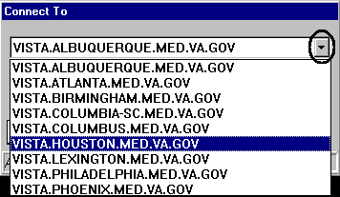

Figure 3 Connect To Window

**Step 4** – **OPTIONAL** – The user clicks **OK**

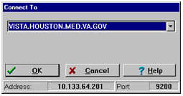

Figure 4 Connect To Window Selection

**Step 5** – The user enters a VistA Access Code, presses the **Tab** key, and then enters the Verify Code. The user then presses **Enter** or clicks **OK**. This takes the user to the Patient Selector Screen.

Note: New users without access codes should contact local IRM staff to get one.

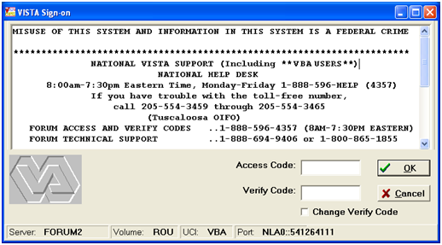

Figure 5 VistA Sign-on

## Regional Office CAPRI Remote Users

Most VBA users are CAPRI Remote users. Each CAPRI Remote user needs only one Access Code and one Verify Code to connect to authorized VA Medical Center (VAMC) sites.

**Step 1** – From the Start/VBAPPS/CAPRI Remote/CAPRI Remote menu, the user clicks the **CAPRI** icon.

**Step 2** –After entering the VistA Access Code, the user presses the **Tab** key to go to the next field and enters the Verify Code. Then the user presses **Enter** or clicks **OK**

***Note:*** *New users without access codes should contact local IRM staff to get one. The first time the user logs into a VistA application, only the Access Code should be entered. CAPRI will then prompt the user to create a Verify Code. Most users should have a valid Access and Verify Code combination by the time they use CAPRI.*

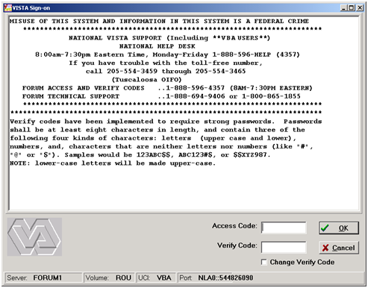

Figure 6 VistA Sign-on Enter Access/Verify

**OPTIONAL** – To change the **Verify Code**, the user selects the **Change Verify Code** checkbox on the sign-on dialog before clicking **OK**. The user will then be prompted to create a new **Verify Code** as shown in the steps in the following screenshot.

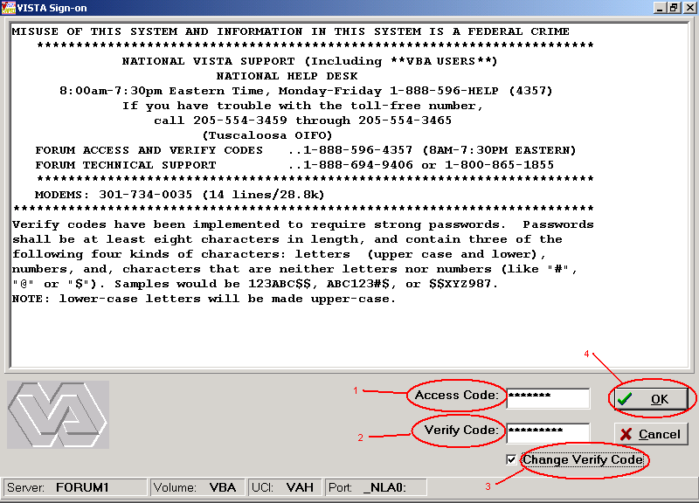

Figure 7 VistA Sign-on – Change Access/Verify code

After selecting **OK**, the user is prompted to enter and confirm a **New Verify Code**

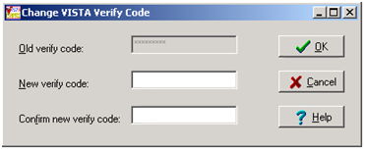

Figure 8 Change Verify Code

**Step 3** – The CAPRI Remote site selection screen displays the user’s authorized VHA facilities. (These accesses are established when an account is initially created and/or the user request specific facilities along with the proper approvals after the account creation. This facility information is located in the CAPRI file 396.96.) When the user selects a CAPRI Remote site executable it provides the authorized remote sites. If shown, the vertical scrollbar is used to scroll through all authorized sites. The user selects a site and then either double-clicks the site’s name or clicks **OK** to access that site. CAPRI has been modified to include the city and state where each facility is located. In addition, the list may now be sorted by State. The following screenshot shows DEV/FEX Test System in Troy, New York as the selected VHA facility.

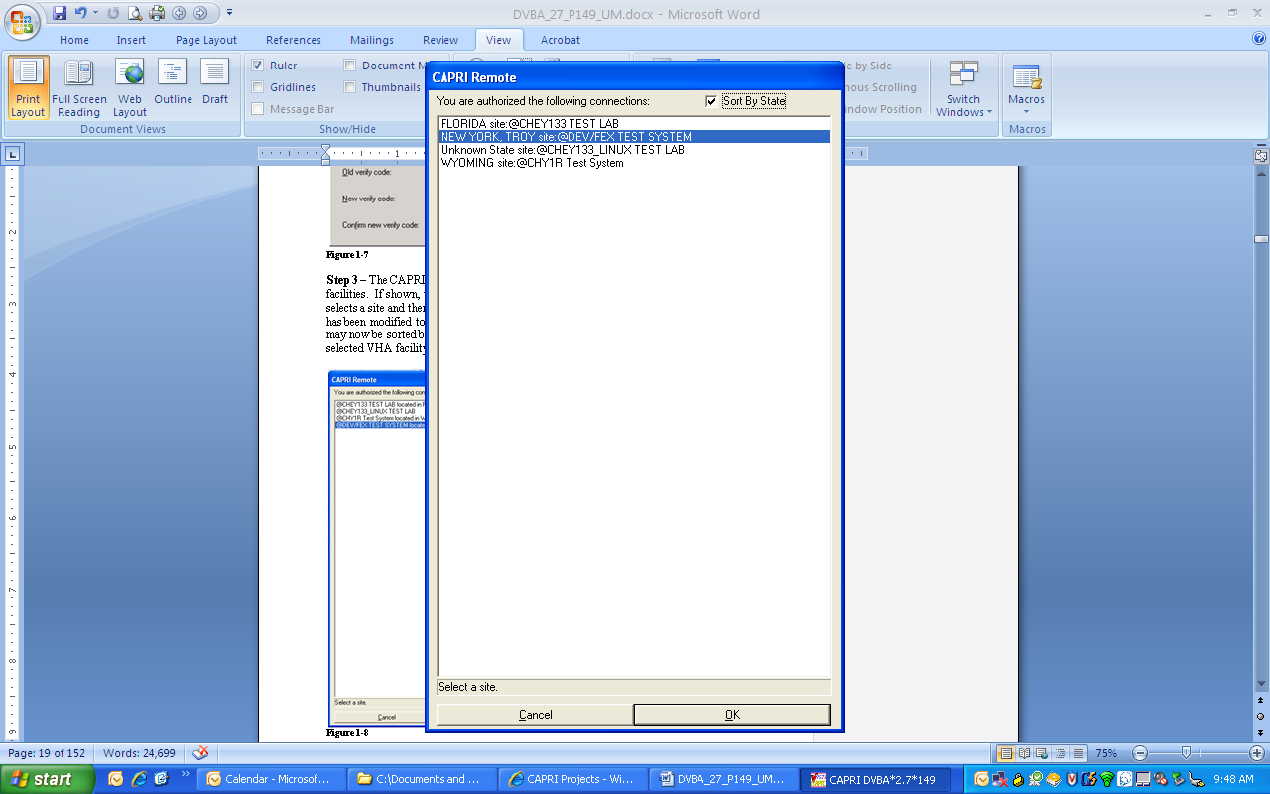

Figure 9 CAPRI Remote Site Selection Screen

After CAPRI loads the VHA facility, the user is prompted with the Patient Selector screen. Instructions for use of the Patient Selector screen are found in section “CAPRI – Using the Software” of the latest version of the CAPRI GUI User Manual at the following URL: <http://www.va.gov/vdl/application.asp?appid=133>

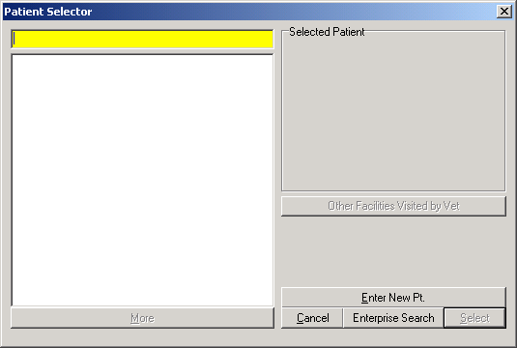

Figure 10 Patient Selector Screen

## CAPRI Remote Users

CAPRI Remote users access CAPRI through the Claims system, which runs on the VHA Forum hardware. The server for those users should be set to **CLAIMS.MED.VA.GOV**, port **9400** (see screenshot below).



Figure 11 Test Claims Properties

CAPRI Remote users outside of VBA will normally obtain an access code from the Office of Information (OI) support staff, not from the local field site. Most VBA users are CAPRI Remote users. Most VHA users are local site users. If a user starts CAPRI and does not successfully connect to a VistA system within 90 seconds, CAPRI automatically shuts down.

When users log into CAPRI remotely, CAPRI alerts users when no email account is set up.

For additional information see the CAPRI Remote Functionality section in the CAPRI GUI User Manual at the following URL: <http://www.va.gov/vdl/application.asp?appid=133>

## VistA Terminal

The “Attachmate Reflections Secure Shell” application replaces the telnet window. CAPRI Remote users can launch a VistA Terminal session by selecting the VistA button to log into the local VistA system site they are assigned to. A dialog box is displayed when the VistA button is clicked that provides the user the ability to choose between connecting using the secure shell application or telnet. The default is set to secure shell application.

Note: Local CAPRI users will not have access to the VistA Terminal from CAPRI and the VistA button will not be available.

## Terminal Server Users

**Step 1** – From the Hines terminal server application, the user double-clicks the **CAPRI** icon.

**Step 2** – Follow the instructions in the previous Section 4.3.2, Regional Office CAPRI Remote Users, **Steps 2** and **3**.

## CAPRI News

Before logging on to CAPRI, News alerts are displayed if new items exist. The user can select the **News** item to view the contents.

The user can select **Clear All** to remove all News items.

The user can select **Close** to continue working with CAPRI.

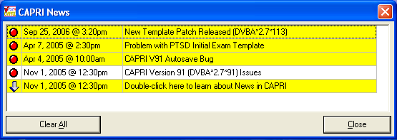

Figure 12 CAPRI News

## CAPRI Alerts

When users of the CAPRI C&P Template functionality log into CAPRI, any existing CAPRI Template Alerts are displayed.

CAPRI automatically checks pending Compensation and Pension Worksheet Module (CPWM) Template statuses. Pending templates in the user’s queue are displayed on the alert screen. The C&P Alert screen displays alerts according to template status. Alerts for template statuses are: **draft**, **awaiting signature**, **sent back from reviewer**, **requiring review**, **CPRS documents to cosign**, **cosigned documents ready to transfer to AMIE, and vendor exam requests pending review.**

The user clicks the **Resolve This Alert** button to be taken to the section of CAPRI where the alert can be resolved. For example, if the user has unsigned templates, then he or she is taken to the **Unsigned Templates** window.

The user may select **Continue** to bypass the alerts and go to the **Patient Selector** screen.

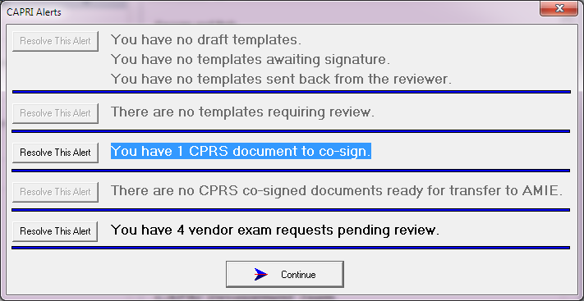

Figure 13 CAPRI Alerts

## Audit Kept

The following instructions are to view your audit log. This is an example only, use your correct information to locate your log.

Example: The log file is named - DVBA_2.7_BuildVersion_dd_mm_yy.TXT

Go to: C:\Documents and Settings\YourVAUserName\Local Settings\Temp\DVBA_2.7_ BuildVersion_dd_mm_yy.txt

# CAPRI Application Maintenance

## CAPRI Application Software Maintenance

The National Patch Module currently resides on the FORUM server and is used to release VistA patches nationally.

Updates to the CAPRI application are distributed through the VA FORUM National Patch Module (NPM) under the DVBA namespace. The DVBA namespace is shared with the Automated Medical Information Exchange (AMIE) package. Patch names follow the format “DVBA*Version*PatchNumber.”

The patch consists of the patch description and the routines and VistA FileMan components in PackMan format for installation on the VistA server. The patch description consists of an overview description of the patch, a functional overview, a list of the components released by the patch, retrieval instructions for the software and documentation, and installation instructions for the VistA server portion of the patch.

CAPRI executable and documentation associated with the patch are retrieved from an FTP server designated by the VA for software downloads. The software retrieval instructions are always added by the developer in the SOFTWARE AND DOCUMENTATION RETRIEVAL section of the patch description. A separate installation guide is provided with each CAPRI patch that provides instructions for installing the CAPRI GUI. New versions of the CAPRI GUI do not require installation of previous versions.

The Associated Patches section of the Patch Description lists any previous patches that must be installed prior to the new patch. The Functional Overview section of the patch describes the functional and technical changes included in the patch. The Installation Requirements section provides detailed instructions on the installation of all patch components.

When a CAPRI patch includes new GUI, the Software and Documentation Retrieval section indicates the name of the GUI distribution (zip) file, the installed executable version, and the file size. This section also provides primary and alternative FTP download locations of the installation file, any Release Notes, and other updated documentation files. Updated patch documentation is uploaded to the VDL within three days of the patch release at the following URL:

<http://www.va.gov/vdl/application.asp?appid=133>

When a CAPRI patch contains a new GUI version, users should be aware of any notes regarding the timing of installation of the M components and providing the new GUI to users.

VA staff with access to FORUM can subscribe to receive notification of newly released CAPRI patches by selecting the FORUM “Patch User Menu” option, “Select Packages for Notification” sub-option, then selecting the AMIE package.

## C&P Worksheet Template Maintenance

CAPRI template files are in an ever evolving environment. To obtain the latest information available information it is best to retrieve a list each time.

CAPRI examination templates are stored in the CAPRI TEMPLATE DEFINITION file. This file maintains a list of definitions used to generate examination templates in the CAPRI Graphical User Interface (GUI). Entries in the CAPRI TEMPLATE DEFINITION file are used by the CAPRI application to create the examination templates in the CAPRI GUI. Retired template definitions are retained in the file for historical purposes. This file should remain standardized between all sites. No additions, modifications, or editions should be made to this file except through the remote PUSH utility.

Entries in the CAPRI TEMPLATE DEFINITION file are maintained remotely. The Business Engineering Services Team (BEST) team manages the CAPRI TEMPLATE DEFINITION file using the CAPRI Template PUSH utility. Organizationally, the (BEST) falls under Systems Management within the VHA Chief Business Office (CBO). Insight into this utility can be gained from the CAPRI PUSH DBQ Utility User Manual document at the following URL:

<http://www.va.gov/vdl/application.asp?appid=133>

This utility is used only by VBA Comp Service. PUSH utility users log onto the CLAIMS Server for authentication and verification. The user performing a PUSH operation must be assigned the option DVBA MANAGE CAPRI TMPLTES GUI option. This option exists only on the CLAIMS and TEST CLAIMS systems, since this is where the operator is authenticated and where the initial context is created. The option DVBA CAPRI GUI is used to create the context for connection to sites where the template definitions are actually updated. Questions about and issues with the PUSH utility should be addressed to: VBA Comp Service

# Applications Development Tools and Usage

# Code Repository Tool (Version Control)

The Delphi application utilizes the Rational Team Concert tool for version control. Its VA approval documentation is located at URL: <http://www.va.gov/TRM/ToolPage.asp?tid=39>

# CAPRI Source Files for Delphi 2006

The CAPRI application is developed in Delphi 2006. Standard source file name extensions are preserved as required by the development tool. These file name extensions are .dfm, .pas, .res, and .drc

The CAPRI source files are stored on a Rational ClearQuest Server. Your code must be checked into ClearQuest once modifications have passed testing by the developer.

Due to the longevity of the CAPRI project only limited unit description and usage is available. The developer will need to reference the CAPRI GUI User Manual to obtain and understand what logic occurs when executing the application. By using the CAPRI GUI User Manual, adding break points in the Delphi 2006 IDE, the developer will obtain an understanding of the Functions, Procedures, RPCs, input and output file, and parameter list and usage.

Select the latest version of the CAPRI GUI User Manual at the following URL: <http://www.va.gov/vdl/application.asp?appid=133>

For any additional assistance refer to Section 1.4, CAPRI Technical Support, for contact information.

# Remote Procedure Calls

## CAPRI Remote Procedure Calls Logger

The RPC Logger was created to better identify errors received in the field. Only members of the IT support team will have the ability to view the log file. By default, the RPC Logger is set to **OFF** and is controlled by a command line parameter in the Shortcut Target line. Below are the defined command line parameters accepted to control the status of the RPC Logger:

* CAPRI will accept the command line parameters **CH=**
* Omitting the **CH=** parameter or setting **CH=0** will turn off the RPC Logger.
* The CH= parameter can be followed by any number. The number will represent the number of days to keep the log before writing over the data stored. For example, the command line parameter **CH=3** will turn on the RPC Logger and store data for 3 days. On the 4th day the logger will be deleted and start storing data for another 3 days.

## CAPRI Remote Procedure Calls (RPCs) for MUMPS

See (Appendix A - CAPRI Remote Procedure Calls) for a list of detailed RPCs used by the CAPRI Graphical User Interface (GUI) software.

To duplicate the list of RPCs in Appendix <>, do the following:

1. Type "D P^DI" to start FileMan.

2. At "Select OPTION:", select option 2, "PRINT FILE ENTRIES.”

3. At "OUTPUT FROM WHAT FILE:", enter "REMOTE PROCEDURE.”

4. Accept the default for "SORT BY: NAME//" by hitting RETURN.

5. At "START WITH NAME: FIRST//", enter "DVBA" to start with the first CAPRI RPC name.

6. At "GO TO NAME: LAST//", enter "DVBC" to list all of the CAPRI namespace RPCs.

7. Accept the default for "WITHIN NAME, SORT BY:"

8. At "FIRST PRINT FIELD:", Enter a "?" and then "Y" for "Do you want the entire nn-Entry FIELD list?". The list will be displayed for you to choose from.

9. At "FIRST PRINT FIELD:" prompt, enter ".01" for NAME. At each successive "THEN PRINT FIELD:" prompt, enter the field numbers listed here:

.02 TAG

.03 ROUTINE

.04 RETURN VALUE TYPE

.06 INACTIVE

1 DESCRIPTION (word-processing)

2 INPUT PARAMETER

At "THEN PRINT INPUT PARAMETER SUB-FIELD:" after entering "2,” click RETURN to bypass sub-fields.

3 RETURN PARAMETER DESCRIPTION

10. At the next "THEN PRINT FIELD:", press RETURN to complete the list of desired fields.

11. For the heading, answer "Replace" with "REM...,” then answer "With" with RETURN to remove a heading, or enter a heading.

12. At the "STORE PRINT LOGIC IN TEMPLATE:" select or create a Print Template, or take the default to bypass creating a print template.

13. At "DEVICE:", answer "0;80;99999" to display the RPC listing to your screen.

Copy and paste the results into a word processing application for possible cleanup.

This is an example of the dialog:

Display the RPC listing to your screen, and then copy and paste the results into a word processing application


Figure 14 Display the RPC listing to your screen

# FileMan

## Installation Procedures and Usage

All VA FileMan documentation is available on the VDL, accessible at the following URL: <http://www.va.gov/vdl/application.asp?appid=5>

There is also additional documentation regarding other FileMan information i.e. FileMan Tips, etc.… is accessible at: <http://www.hardhats.org/index.html>

***Note:*** *Using the Freedom of Information Act this website obtained documentation from the VA for VISTA. In general this site gathers information from multiple sources including the VA website.*

### Environmental Setup

The VA FileMan V.22 Key and Index Tutorial document contains the environmental setup information at the following URL: <http://www.va.gov/vdl/application.asp?appid=5>

### Installation Guide

Access the VA FileMan Installation Guide at: <https://www.va.gov/vdl/application.asp?appid=5>

### Getting Started

Access the VA FileMan Getting Started User Manual at: <https://www.va.gov/vdl/application.asp?appid=5> FileMan Access Codes

The following table is a list of recommended VA FileMan access codes associated with each file contained in the AMIE software.

| **FILE NUMBER** | **FILE NAME** | **DD ACCESS** | **RD ACCESS** | **WR ACCESS** | **DEL ACCESS** | **LAYGO ACCESS** |
| --- | --- | --- | --- | --- | --- | --- |
| 31 | Disability Condition | @ | D | @ | @ | @ |
| 396 | Form 7131 | @ | # | # | # | # |
| 396.1 | AMIE Site Parameter | @ | # | # | @ | @ |
| 396.2 | AMIE Report | @ | # | # | # | # |
| 396.3 | 2507 Request | @ | # | # | # | # |
| 396.4 | 2507 Exam | @ | # | # | # | # |
| 396.5 | 2507 Cancellation Reason | @ | # | @ | @ | @ |
| 396.6 | AMIE Exam | @ | # | @ | @ | @ |
| 396.7 | 2507 Body System | @ | # | @ | @ | @ |
| 396.94 | 2507 Insufficient Reasons | @ | # | @ | @ | @ |
| 396.95 | AMIE C&P Exam Tracking | @ | # | # | # | # |

***Note:*** *The code (symbol) “@” in this table is the programmer’s access. The other codes are arbitrary, and are determined by the developers during the design phase and assigned as needed to users by the Information Systems (IS) staff in the File Manager Access Code field of the New Person (#200) file.*

### Advanced User

Access the VA FileMan Advanced User Manual at:

<https://www.va.gov/vdl/application.asp?appid=5>

### Programmer Manual

Access the VA FileMan Programmer Manual at:

<https://www.va.gov/vdl/application.asp?appid=5>

### Technical Manual

Access the VA FileMan Technical Manual at:

<https://www.va.gov/vdl/application.asp?appid=5>

### Package-wide Variables

There are no package-wide or special variables in the AMIE software.

#### Key Variables

* PNAM = Patient name
* DFN = Internal ^DPT number
* SSN = Social security number
* CFLOC = Claim folder location
* DCHGDT = Discharge date
* ADMDT = Admission date

#### How to Generate Online Documentation

This section describes some of the various methods by which users may secure AMIE technical documentation. Online technical documentation pertaining to the AMIE software, in addition to that which is located in the help prompts may be generated through utilization of several Kernel options. These include XINDEX and VA FileMan List File Attributes. Further information about other utilities which supply online technical documentation may be found in the Kernel Reference Manual.

#### XIndex

This option analyzes the structure of a routine(s) to determine in part if the routine(s) adheres to VistA Programming Standards. The XINDEX output may include the following components: compiles list of errors and warnings, routine listing, local variables, global variables, naked globals, label references, and external references. By running XINDEX for a specified set of routines, the user is afforded the opportunity to discover any deviations from VistA Programming Standards which exist in the selected routine(s) and to see how routines interact with one another, that is, which routines call or are called by other routines.

To run XINDEX for the AMIE software, specify the following namespace at the "routine(s) ?>" prompt: DVBA* and DVBC*. AMIE initialization routines which reside in the UCI in which XINDEX is being run, as well as compiled template routines found within the AMIE namespace, should be omitted at the "routine(s)?>" prompt. To omit routines from selection, preface the namespace with a minus sign (-).

##### Data Dictionary List File Attributes

This VA FileMan option allows the user to generate documentation pertaining to files and file structure. Utilization of this option via the "Standard" format will yield the following data dictionary information for a specified file(s): file name and description, identifiers, cross-references, files pointed to by the file specified, files which point to the file specified, input templates, print templates, and sort templates. In addition, the following applicable data is supplied for each field in the file: field name, number, title, global location, description, help prompt, cross-reference(s), input transform, date last edited, and notes.

Using the "Global Map" format of this option generates an output which lists all cross-references for the file selected, global location of each field in the file, input templates, print templates, and sort templates.

For a comprehensive listing of AMIE files used by CAPRI, please use the following link (URL) to locate the “Files” section of the AMIE Technical Manual: <http://www.va.gov/vdl/application.asp?appid=31>

# Archiving, Purging, and Frequency

CAPRI relies on the AMIE application for any archiving and purging functionality.

Although the AMIE software has no archiving capabilities AMIE’s purging capabilities are handled by the DVBA REGIONAL PURGING PROGRAM option deletes all FINALIZED requests which are older than the date set in the AMIE SITE PARAMETER file (#396.1). It should normally be set to run daily on TaskMan, as it takes several minutes to run in programmer mode. In addition to purging the FORM 7131 file (#396), it also purges the AMIE REPORT file (#396.2).

The frequency is based on the amount of 7131 information purged by this program. It is determined by the NUMBER OF DAYS TO KEEP HISTORY parameter set through the Regional File Site Parameter Setup option. It is suggested to keep at least 30 days on file at all times, but no more than 120 days. The NUMBER OF DAYS TO KEEP HISTORY field (#9) of the AMIE SITE PARAMETER file (#396.1) will automatically keep 30 days of report data if no value is in that field.

While the AMIE software uses a very small amount of disk space, it is wise not to let the data accumulate if it is not needed by the hospital.

The DVBA C Purge 2507 option deletes all 2507 requests with the following statuses and that are older than the number of days in the DAYS TO KEEP 2507 HISTORY parameter: Completed, Printed by RO; Completed, Transferred Out; Cancelled by Medical MAS; Cancelled by RO. This option should be scheduled through TaskMan to run nightly. It may be run in programmer mode but will take several minutes. The 2507 EXAM (#396.4) file will be purged in conjunction with the 2507 REQUEST file (#396.3).

# Security

## Security Management

VA Directive 10-93-142 prohibits local modifications to VistA software.

## General Security

For CAPRI GUI security refer to the most current CAPRI User Manual. This manual includes instructions for setting up CAPRI users, as well as descriptions of all Security Keys used by the CAPRI GUI application.

See the CAPRI GUI User Manual at: <http://www.va.gov/vdl/application.asp?appid=133>

### Remote Systems

The AMIE software does not transmit data to any remote systems. For CAPRI interactions with remote systems, refer to the Systems Architecture diagram in Section 3.1.1.

### Contingency Planning

Your facility should have a local contingency plan in the event of application problems in a live environment. It should identify the procedure for maintaining functionality provided by the AMIE software as well as the CAPRI GUI application, in the event of system outage.

### Interfacing

There are no special interfacing requirements for the AMIE or the CAPRI software.

### Electronic Signatures

The CAPRI GUI application uses electronic signatures. Use the following link to locate the CAPRI GUI User Manual: <http://www.va.gov/vdl/application.asp?appid=133>

### Security Keys

Take the following steps to get information about the security keys used with the AMIE software.

1. VA FileMan Menu

2. Print File Entries Option

3. Output from what File: SECURITY KEY

4. Sort by: Name

5. Start with name: DVBA to DVBC

6. Within name, sort by: <RET>

7. First print field: Name

8. Then print field: Description

***Note:*** *Some keys do not affect the menu operation. This is due to some options having several different functions which are limited in scope by the key. This limitation is done internally by the program being used.*

# CAPRI Troubleshooting and Error Information

Note: In all cases, please print the error message for your local IRM staff.

A majority of CAPRI issues that are initially called into the Service Desk or are created into ServiceNow tickets are not often CAPRI related issues, but are due to other issues regarding networks and users accesses/permissions, etc... Those few CAPRI issues that are identified as a CAPRI issue are forwarded onto the CAPRI Team. The team works to replicate and identify the issue, then to develop solutions or workarounds to correct or eliminate the issue. Some of these issues result in identification of a CAPRI defect or an issue that may become a future CAPRI enhancement. These issues are often unique and not reported in any significant numbers. The CAPRI Team forwards these specific issues onto the VA who will determine if the issue(s) is something that should be recognized as a defect or a possible CAPRI enhancement scheduled for one of the next CAPRI patch installation deployment.

The remainder of this section includes general CAPRI troubleshooting and error information that is located in the CAPRI GUI User Manual at the following URL: <http://www.va.gov/vdl/application.asp?appid=133>

Select the latest version of the document; refer to the section “Troubleshooting and Error Messages.”

## CAPRI Not Installed in VistA

The user receives the message in the following screenshot if the VHA Medical Center has not loaded the VHA half of the CAPRI software. The user should contact local IRM staff after receiving this message.

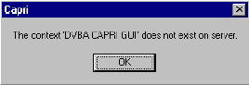

Figure 15 CAPRI Not Installed in VistA Error Message

## CAPRI GUI Option Not Assigned to User in VistA

The user receives the message in the following screenshot if the VHA medical center has not assigned the CAPRI option to RO users. The user must contact local IRM staff upon receiving this message.

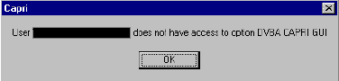

Figure 16 CAPRI GUI Option Not Assigned to User in VistA

## VistA Server Down

The user receives the message in the following screenshot, or a similar one such as WSAETIMEDOUT, when there are performance issues in the VA Wide Area Network (WAN), if a server is down, or if a server was not restarted after being down. When this happens, AMIE II may or may not connect, depending on the exact problem. The user should test the AMIE II connection.

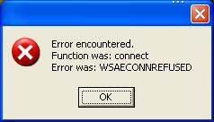

Figure 17 VistA Server Down Error Message

## VistA Limits Ability to See Patient Records

The user receives the message in the following screenshot if the medical facility made local permission modifications in VistA that prohibit users from seeing the contents of patient records.

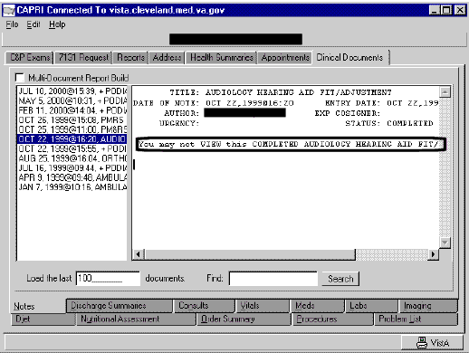

Figure 18 VistA Limits Ability to See Patient Records

## Network Problems

The user receives the message in the following screenshot if the connection to the medical facility is lost unexpectedly. The user should try to connect to the medical facility again.

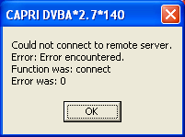

Figure 19 Could not connect to Remote Server Error Message

## Institution File in VistA has Been Locally Modified

The user may receive the message in the following screenshot when requesting exams, requesting 7131s, or entering new patients if the VHA medical facility has an incomplete or incorrect Regional Office list in their system.

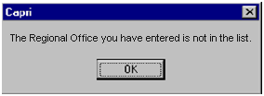

Figure 20 Incomplete or Incorrect Regional Office

## Too Many Invalid Attempts at Access Code / Verify Code

The user receives the message in the following screenshot if the user attempted to log on and entered the wrong Access Code / Verify Code combination three or more times.

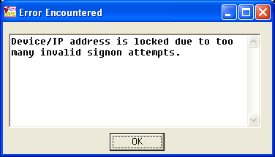

Figure 21 Device locked due to multiple sign-on message

## Multiple Sign-Ons

The user may receive the message in the following screenshot if the user did not log out of CAPRI correctly or if the session was unexpectedly disconnected.

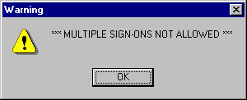

Figure 22 Multiple Sign-ons error Message

## General Error Message

The user may receive the message in the following screenshot for a number of reasons. Upon receiving this message, the user should cancel the current task, close CAPRI, and sign on again. If the user receives this error message again, local IRM staff should be contacted for assistance.

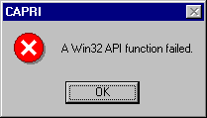

Figure 23 General Error Message

# Appendix A - CAPRI Remote Procedure Calls for MUMPS

The DVBA CAPRI GUI menu option contains all the CAPRI RPCs.

Name: DVBA CAPRI GUI

Menu Text: Capri GUI (Broker)

Type: Broker (Client/Server)

Package: AUTOMATED MED INFO EXCHANGE

Description: This is the “B” type option used by CAPRI GUI client application. It contains all the RPCs used by the CAPRI GUI application.

The table that starts on the next page shows a correlation between the CAPRI’s MUMPS RPCs and DELPHI’s RPCs associated within supporting the CAPRI application.

| **MUMPS** | | | | | | | | | | | | | | | | **DELPHI** | | | | | | | | | | | |
| --- | --- | --- | --- | --- | --- | --- | --- | --- | --- | --- | --- | --- | --- | --- | --- | --- | --- | --- | --- | --- | --- | --- | --- | --- | --- | --- | --- |
| NAME | | TAG | | ROUTINE | | RETURN  VALUE  TYPE | | DESCRIPTION | | INPUT  PARAMETER  (Multiple) | | RETURN PARAMETER  DESCRIPTION | | | | **Procedure Name** | | | **Locations** | | | | **Broker Name** | | | **Parameter** | |
| DG SENSITIVE RECORD ACCESS | | PTSEC | | DGSEC4 | | ARRAY | | This Remote Procedure Call (RPC) will:  - Verify user is not accessing his/her own Patient file record if the Restrict Patient Record Access (#1201) field in the MAS parameters (#43) file is set to yes and the user does not hold the DG RECORD ACCESS security key. If parameter set to yes and user is not a key holder , a social security number must be defined in the New Person file for the user to access any Patient file  record.  - Determine if user accessing a sensitive record or an employee's record | |  | | RESULT(1) =  -1-RPC/API failed Required variable not defined  0-No display/action required Not an employee, not sensitive or not accessing own Patient record  1-Display warning message Sensitive - inpatient or a DG SENSITIVITY key holder or Employee and DG SECURITY OFFICER key holder  2-Display warning message, require OK to continue and call DG SENSITIVE RECORD BULLETIN RPC to update DG Security Log file and generate Sensitive Record Access mail message. Sensitive - not an inpatient and not a key holder or Employee/not a DG SECURITY OFFICER key holder  3-Access to record denied Accessing own Patient file record  4-Access to Patient file (#2) records denied SSN not defined RESULT(2-n) = error message or warning/Privacy  Act message. Error and warning messages will begin in RESULT(2) array. The Privacy Act message is the longest message and will utilize RESULT(2)- RESULT(8).   If RESULT(1)=1, the DG Security Log file is updated.  If RESULT(1)=2, the user must acknowledge they want to access the restricted record and the application must call the DG SENSITIVE RECORD BULLETIN RPC to update the DG Security Log file and generate the Sensitive Record Access mail msg | | | | DG SENSITIVE RECORD ACCESS'  'DG SENSITIVE RECORD ACCESS' | | | patientlist  patientlistrestricted | | | | RPCBroker1    RPCBroker1 | | | FMCvrListBox1Pt.GetselectedRecord.IEN or FMCvrListBox2Pt.GetselectedRecord.IEN or FMCvrListBox3Pt.GetselectedRecord.IEN PType := literal; for all params  FMListBox1.GetSelectedRecord.IEN; PType := literal; | |
| DG  SENSITIVE  RECORD  BULLETIN' | | NOTICE | | DGSEC4 | | SINGLE | | This Remote Procedure Call (RPC) will add an entry to the DG SECURITY LOG (#38.1) file and/or generate the sensitive record access bulletin depending on the value in ACTION input parameter. If ACTION parameter not defined, defaults to update DG Security Log file and generate Sensitive Record Access mail message. | | NONE | | RESULT=  1 - successfully added entry and/or generated sensitive record access bulletin  0 - unsuccessful | | | | DG SENSITIVE RECORD BULLETIN' | | | patientlistrestricted | | | | RpcBroker1 | | | PatientIEN PType := literal; 'DVBA CAPRI GUI^Capri GUI (Broker)' PType := literal; ' '  PType := literal; | |
| DVBA CAPRI EXAM LINK TIU | | **LINK** | | **DVBAXML** | | **SINGLE VALUE** | | Links an exam in CAPRI TEMPLATES #396.17 to TIU DOCUMENT #8925 | | **EXAMIEN**  **TIUIEN** | | returns 1 if the exam has been successfully linked to the TIU DOCUMENT;  otherwise return 0^error message | | | | DVBA CAPRI EXAM LINK TIU | | | tiusign | | | | RpcBroker1 | | | PNCSForm.xFMEdit2.IENS  PType := literal;  TIUNoteIEN;  PType := literal; | |
| DVBA  CAPRI EXAM XML | | **FILEIN** | | **DVBAXML** | | **SINGLE VALUE** | | This RPC allows for the filling of the 2507 EXAM template in the XML  version. | | **EXAMIEN**  **DAS**  **XML** | | XML is the array list format of the template being stored  RETURN PARAMETER DESCRIPTION:  Y Returns successful filing status or error message | | | **DVBA CAPRI EXAM XML** | | | | | | **Tiusign** | **RpcBroker1** | | | **AnExamIEN;**  **PType := literal;**  **CAPRI_InhouseExamXMLNote;**  **PType := literal;**  **List of files**  **uuEncodedFile**  **PType := list;** | | |
| DVBA CAPRI GET EDIPI | | EDIPIQ | | DVBCENQ | | **SINGLE VALUE** | | Capri Remote Procedure Call Returns EDIPI To Be Sent Via DBQ's To DoD | | **DFN** | | Capri Remote Procedure Call returns an EDIPI number from File 391.91.  If no number is found, it returns 0 | | | DVBA CAPRI GET EDIPI | | | | | | VlerEDasClaim | RPCBroker1 | | | **PatientIEN** | | |
| DVBA CAPRI GET EDIPI2 | | EDIPIQ | | DVBCENQ | | **ARRAY** | | Capri Remote Procedure Call returns an EDIPI and Branch of Service to be sent via DBQs to DoD | | **DFN** | | Capri Remote Procedure Call returns an EDIPI number from File 391.91 and Branch of Service from File 2. The Default return for a NULL value is 0. | | | DVBA CAPRI GET EDIPI | | | | | | VlerEDasClaim | RPCBroker1 | | | **PatientIEN** | | |
| DVBA CAPRI GET EXAM IEN | | **GETEXAM** | | **DVBXML** | | **SINGLE VALUE** | | get an exam ien from the CAPRI TEMMPLATE #396.17 given a  tiu ien from TIU DOCUMENT #8925 | | **TIUIEN** | | returns a integer greater than zero if the exam can be found;  otherwise return -1^error message | | | **DVBA CAPRI GET EXAM IEN** | | | | | | **Tiusign** | **RpcBroker1** | | | **TiuDocumentIen**  **PType := literal;** | | |
| DVBA CAPRI GETCANCELREASON | | **CANRSN** | | **DVBCANRS** | | **ARRAY** | | This returns an array of active 2507 EXAM Cancellation Reasons. New  active reasons added with Patch DVB*2.7*189. Old list of cancellation  reasons set to inactive. | | **LIST** | | Returns a 1 when completed | | | **DVBA CAPRI GETCANCELREASO** | | | | | | **ExamDetail** | **RPCBroker1** | | | **No Params** | | |
| DVBA CAPRI GETCLAIMTYPE | | **GETCT** | | **DVBACPR1** | | **ARRAY** | | This RPC returns a list (array) of Claim Types associated with a valid  2507 Request | | REQIEN | | Returns all Claim Types associated to the valid 2507 Request | | | **DVBA CAPRI GETCLAIMTYPE** | | | | | | **ViewExam** | **RpcBroker1** | | | **RequestIEN;**  **PType := literal;** | | |
| DVBA CAPRI GETSPCLCONSID | | **GETSC** | | **DVBACPR1** | | **ARRAY** | | This RPC returns an array of special considerations linked to a 2507  request. | | **2507 REQUEST IEN** | | **NONE** | | | **DVBA CAPRI GETSPCLCONSID** | | | | | | **ViewExam** | **RpcBroker1** | | | **RequestIEN;**  **PType := literal;** | | |
| DVBA CAPRI LISTCLAIMTYPE | | **LSTCT** | | **DVBACPR1** | | **ARRAY** | | This RPC returns a list (array) of valid Claim Types | | **NONE** | | List of valid Claim Types | | | **DVBA CAPRI LISTCLAIMTYPE** | | | | | | **ViewExam**  **NewExam** | **RpcBroker1** | | | **No params** | | |
| DVBA CAPRI LISTINSUFRSN | | **LSTIR** | | **DVBACPR1** | | **ARRAY** | | This RPC returns a list (array) of valid Insufficient Reasons that can be  linked to a 2507 exam. | | **NONE** | | **NONE** | | | **DVBA CAPRI LISTINSUFRSN** | | | | | | **NewExam** | **RpcBroker1** | | | **No params** | | |
| DVBA CAPRI LISTSPCLCONSID | | **LSTSC** | | **DVBACPR1** | | **ARRAY** | | This RPC returns an array (listing) of valid special considerations that  can be linked to a 2507 request. | | **NONE** | | **NONE** | | | **DVBA CAPRI LISTSPCLCONSID** | | | | | | **NewExam**  **ViewExam** | **RpcBroker1** | | | **No params** | | |
| DVBA CAPRI SETCLAIMTYPE | | **SETCT** | | **DVBACPR1** | | **ARRAY** | | This RPC returns the status of Claim Types passed to be set to a valid  2507 Request | | **ARRACT** | | Returns status of Claim Type sets | | | **DVBA CAPRI SETCLAIMTYPE** | | | | | | **NewExam**  **ViewExam** | **RpcBroker1** | | | **RequestIEN**  **PType:= literal;**  **cbClaimType.Items[cbClaimType.ItemIndex]**  **PType := List** | | |
| DVBA CAPRI SETSPCLCONSID | | **SETSC** | | **DVBCAPR1** | | **SINGLE VALUE** | | This RPC sets the passed-in special considerations and links them to the  passed-in 2507 request. | | **2507 REQUEST IEN**  **SPECIAL CONSIDERATION LIST** | | **NONE** | | | **DVBA CAPRI SETSPCLCONSID** | | | | | | **NewExam**  **ViewExam** | **RpcBroker1** | | | **RequestIEN;**  **PType := literal;**    **chklstSpecialConsiderations.Items[i];**  **PType := list;** | | |
| DVBA CHECK PATCH | | CHEC | | DVBAB1B | | SINGLE VALUE | | This RPC is a wrapper for the supported $$PATCH^XPDUTL API to determine whether a given patch is installed or not "1^Patch Is Installed" is returned on success; otherwise "0^Patch Is Not Installed" is returned. | | DVBPATCH | | Returns "1^Patch Is Installed" on success; otherwise returns "0^Patch Is Not Installed". | | | DVBA CHECK PATCH' | | | | | | CAPRISupport | RPCBroker1 | | | No Params | | |
| DVBAB DIVISION | | **DIVISION** | | DVBAB1 | | **SINGLE VALUE** | | **None** | | **None** | | **None** | | | **DVBAB DIVISION** | | | | | | **Main** | **RpcBroker1** | | | **No Params** | | |
| DVBA MVI GET CORRESPONDING IDS | | **GETIDS** | | **DVBAMVI2** | | **LITERAL** | | This is the Integration Control Number (ICN) used to identify the patient that is selected from the MVI SEARCH PERSON web service results.  Format: "1008523099V750710^NI^200M^USVHA^" | | **SOURCE ID** | | List of VAMC treating facilities associated with the passed identifier. Each line contains INSTITUTION (#4) file IEN, station name ,and station number delimited by a caret ("^"). The first entry in the list contains the total number of stations returned. Format: instutionIEN^stationName^stationNumber  Example: DVBOUT(0)=2  DVBOUT(1)="516^BAY PINES VA HCS^516"  DVBOUT(2)="523^BOSTON HCS VAMC^523" | | | **DVBA MVI GET CORRESPONDING IDS** | | | | | | **frmMVISearch** | **RPCBroker1** | | | **None** | | |
| DVBA MVI SEARCH PERSON | | **FINDPAT** | | **DVBAMVI1** | | **ARRAY** | | This remote procedure passes the delimited person traits to the MVI  SEARCH PERSON web service and returns the results of the search. | | PERSON TRAITS  INITIAL QUANTITY  NAME FORMAT | | The zero array node returns the caret-delimited record count and search status results.  Piece 1: Returned record count  Piece 2: OK or error message text  Array node 1 starts the list of caret-delimited matching patient records.  Piece 1: FULLNAME  Piece 2: SSN (9 digits)  Piece 3: DATE OF BIRTH (external format)  Pieces 4-7 contain the MVI ID components  Piece 4: ID  Piece 5: IdType  Piece 6: Assigning Location  Piece 7: Assigning Issuer  Example results:  Default name format:  R(0)=2^OK  R(1)=CAPRI PATIENT^111905454^01/01/1980^1062212234V192931^NI^200M^USVHA  R(2)=CAPRI T PATIENT^111905454^01/01/1980^1008591712V479586^NI^200M^USVHA  VistA name format:R(0)=1^OK  R(1)=PATIENT,CAPRI T^111905454^01/01/1980^1008591712V479586^NI^200M^USVHA  Error:  R(0)=0^Acknowledgement Error: Multiple Matches Found[4] | | | **DVBA MVI SEARCH PERSON** | | | | | | **frmMVISearch**  **HIAVerifyPatient** | **RPCBroker1** | | | **SearchString**  **PType:= literal;**  **SearchResultNumParam**  **PType:= literal;** | | |
| DVBAB 2507 PENDING REPORT | | **STRT** | | **DVBAB6** | | GLOBAL ARRAY | | Generates a report based on the status of 2507 requests. | | **DVBCSORT**  **RSTAT**  **ERDAYS**  **OLDAYS**  **ELTYP** | | MSG is returned. | | | DVBAB 2507 PENDING REPORT | | | | | | Not called in Delphi code | Not called in Delphi code | | | Not called in Delphi code | | |
| DVBAB 8861 NOTIFICATIONS | | ENTER | | DVBANTFY | | SINGLE VALUE | | This will perform MailMan notifications for Form 8861 Requests based on the status of the request. | | **IEN**  **STAT** | | The RPC returns either a success or failure to send the MailMan notification, either 0 or 1. | | | DVBAB 8861 NOTIFICATIONS | | | | | | **VocRehabClass** | **RPCBroker1** | | | Value := frmVRMedicalRequest.SelectedMedicalRequestIEN, PType := literal  Value := MsgType  PType := literal | | |
| DVBAB AMIS REPORT | | STRT | | DVBAB3 | | ARRAY | | Returns an AMIS report for specified search criteria. | | BDATE  EDATE | | NONE | | | DVBAB AMIS REPORT | | | | | | **RemoteReports,**  **Reports** | **RPCBroker1** | | | **Value := DateTimePickerStart.Date;**  **PType := literal;**  **Value := DateTimePickerStop.Date;**  **PType := literal;**  **Value := aRegionalOffice + '^' + Piece(DivisionList.Strings[i], '^', 2);**  **PType := literal;**  **Value := 'N'; // Just say NO to mailman**  **PType := literal;**  **Value := AuthorIEN;**  **PType := literal;**  **Value := PriorityFilter;**  **PType := literal;** | | |
| DVBAB APPOINTMENT LIST | | DPA | | DVBAB1B | | GLOBAL ARRAY | | Returns a list of past, future or all appointments. | | VAL1  VAL2 | | Returns LIST of appointments for the patient based on value of CHOICE. | | | DVBAB APPOINTMENT LIST | | | | | | MAIN | RPCBroker1 | | | Value := PatientIEN;  PType := literal;  Value := 'P'; //A=All appt. F=Future appt. P=Past appt.  PType := literal; | | |
| DVBAB CCOW | | CCOW | | DVBABFRM | | SINGLE VALUE | | This remote procedure encapsulates the supported calls $$SITE^VASITE  and $$PROD^XUPROD.  Parameter TYPE 1 = Pass back local station number ($$SITE^VASITE)  2 = Pass back whether production account or not ($$PROD^XUPROD) | | INFOTYPE  TYPE | | NONE | | | DVBAB CCOW | | | | | | **Main**  **untBrkrMthds** | **RPCBroker1,**  **Brkr** | | | **Value := '1';**  **PType := literal;**  **Value := '2';**  **PType := literal;** | | |
| DVBAB CHECK CREDENTIALS | | CHKCRED | | DVBAB1 | | SINGLE VALUE | | Verifies the user has been granted access to AMIE II/CAPRI | | NONE | | NONE | | | DVBAB CHECK CREDENTIALS'  'DVBAB CHECK CREDENTIALS' | | | | | | viewaddress     viewexam | RPCBroker1     RPCBroker1 | | | No Params     No Params | | |
| DVBAB DATETIME | | DTTM | | DVBAB1 | | SINGLE VALUE | | Returns the current date/time from VistA | | NONE | | NONE | | | DVBAB DATETIME'  'DVBAB DATETIME' | | | | | | REPORTS   telnet | RPCBroker1   RPCBroker1 | | | No Parms   No Params | | |
| DVBAB DIVISION | | DIVISION | | DVBAB1 | | SINGLE VALUE | | Returns list of divisions | | NONE | | NONE | | | DVBAB DIVISION | | | | | | **Main** | **RPCBroker1** | | | **No Params** | | |
| DVBAB EXAMS BY DATE | | EXAMBYDT | | DVBABEBD | | GLOBAL ARRAY | | Provides a report by date range of all AMIE/CAPRI exam requests. | | BEGDT ENDT | |  | | | | DVBAB EXAMS BY DATE' | | | | REPORTS | | | | RPCBroker1 | | | Value := FMToDateConvert(FormatDateTime('mm/dd/yyyy', DateTimePicker1.DateTime)); PType := literal Value := FMToDateConvert(FormatDateTime('mm/dd/yyyy', DateTimePicker2.DateTime)) PType := literal |
| DVBAB FETCH 1U4N | | U1N4 | | DVBABFRM | | GLOBAL ARRAY | | Retrieve the 1u4n field for the list of patient IENS provided as the only argument. Each IEN will be sent back with field .0905 appended after a caret. | | ARR | | List of Patient IENs in piece 1,followed by 1U4N in piece 2 | | | | DVBAB FETCH 1U4N' | | | | unsigned | | | | RPCBroker1 | | | Mult[IntToStr(i + 1)] := FMListBoxIPR1.GetSelectedRecord.IEN; PType := list; |
| DVBAB FIND DUPS | | DUP | | DVBAB84 | | GLOBAL ARRAY | | Find potential duplicates within the PATIENT File (#2) At least one of NAM, DOB, or SSN must be passed Possible matches are "better" when more than one of these is passed | | NAM DOB SSN | | BYREF - Passed by reference, will contain name of a TMP Global housing the results Subscript 0: -1^ERROR_MESSAGE (in the event of an error) OR Subscript 0: Number of potential matches found (if no errors) Subscript 1-K: Patient's matching ALL 3 of NAM, DOB, SSN have a weighting of 3 (see Note) Subscript K+1-L: Patient's matching ANY 2 of NAM, DOB, SSN have a weighting of 2 (see Note) Subscript L+1-M: Patient's matching ONLY 1 of NAM, DOB, SSN have a weighting of 1 (see Note) ^TMP(1-M) = DFN^ZERO_NODE where DFN is the Patient IEN ZERO_NODE is the data from ^ DPT(DFN,0) NOTE: Potential matches within a weighting (if any) will be sorted by Patient Name | | | | DVBAB FIND DUPS'  'DVBAB FIND DUPS' | | | | EnterPt  entersimple | | | | RPCBroker1  RPCBroker1 | | | nam := LastName.text + ',' + FirstName.text;  nam := LastName.text + ',' + FirstName.text; |
| DVBAB FIND EXAMS | | FINDEXAM | | DVBAB1 | | ARRAY | | Lists all of the patient's AMIE II C&P exam requests whether complete, new or pending. | | INPUT1 | |  | | | | DVBAB FIND EXAMS'   'DVBAB FIND EXAMS'   'DVBAB FIND EXAMS'   'DVBAB FIND EXAMS'    'DVBAB FIND EXAMS'    'DVBAB FIND EXAMS' | | | | ManageReports    loadexamcomments  newexam  tiusign  uncosignedutility     viewexam | | | | RPCBroker1  RPCBroker1  RPCBroker1  RPCBroker1  RPCBroker1  RPCBroker1 | | | FMExamRequestListbox.GetSelectedRecord.IEN PType := literal;  FMExamRequestListbox.GetSelectedRecord.IEN PType := literal;  FMExamRequestListbox.GetSelectedRecord.IEN PType := literal;  Value := FMExamRequestListbox.GetSelectedRecord.IEN; PType := literal;  Value := FMExamRequestListbox.GetSelectedRecord.IEN; PType := literal;  frmMain.FMExamRequestListbox.GetSelectedRecord.IEN; PType := literal; PType := literal; |
| DVBAB FORM COPY | | COPY | | DVBABFRM | | SINGLE VALUE | | Copies a CAPRI form in file 396.17 to a new entry. Clears key field so the form becomes editable as a new draft document.  DVBAB1 = IEN in 396.17 to copy  DVBAB2 = IEN in patient file  If DVBAB2 is null, the copied form will be filed under the same patient it previously belonged to.    If DVBAB2 has a value, it'll be copied to the new patient. | | DVBAB1  DVBAB2 | | Returns the IEN of the newly copied form. | | | | DVBAB FORM COPY | | | | Main | | | | RPCBroker1 | | | Value := FMListBoxIPR1.GetSelectedRecord.IEN;  PType := literal; |
| DVBAB FORM DATA BACKUP | | BACKUP | | DVBABFRM | | SINGLE VALUE | | Makes a backup copy of a CAPRI template in case of data loss. The backup is restored through the CAPRI GUI. | | DVBIEN LISTBOX TEXT | |  | | | | DVBAB FORM DATA BACKUP' | | | | PNCSMain | | | | RPCBroker1 | | | Piece(xFMEdit2.IENS, ',', 1); PType := literal; or 'MANAGE TEMPLATES restore-point' PType := literal; or 'Template CLOSED / ' + VersionUser; PType := literal; or 'TEMPLATE RESTORE restore-point '; PType := literal; or SaveName + ' / ' + VersionUser; PType := literal; or frmMain.RPCBroker1.Param[2].Value + ' / ' + AuthorName; |
| DVBAB FORM DATA BACKUP DELETE | | DELETE | | DVBABFRM | | SINGLE VALUE | | String returned is "^" piece separated, as follows: Piece Item 1 | | IEN | |  | | | | DVBAB FORM DATA BACKUP DELETE'; | | | | tiusign | | | | RPCBroker1 | | | Value := Piece(PNCSForm.xFMEdit2.IENS, ',', 1); PType := literal; |
| DVBAB FORM DATA BACKUP RESTORE | | RESTORE | | DVBABFRM | | SINGLE VALUE | |  | | IEN SIEN | |  | | | | DVBAB FORM DATA BACKUP RESTORE' | | | | PNCSMain | | | | RPCBroker1 | | | Piece(xFMEdit2.IENS, ',', 1); PType := literal; IntToStr(WhichVersionToLoad); PType := literal; |
| DVBAB GET SET | | **GETSET** | | **DVBABDDU** | | **ARRAY** | | This remote procedure retrieves the SET OF CODES for a given file and field for use in populating controls. | | **DVBFIL**  **DVBFLD** | | The results will be returned as an array of strings, each containing the  internal set of codes value and the external set of codes value delimited  by a caret ("^").  Example results:  DVBRSLT(1)="T^TERMINAL"  DVBRSLT(2)="P^POW"  DVBRSLT(3)="OS^ORIGINAL SC"  DVBRSLT(4)="ON^ORIGINAL NSC"  DVBRSLT(5)="I^INCREASE"  DVBRSLT(6)="R^REVIEW"  DVBRSLT(7)="OTR^OTHER" | | | | DVBAB GET SET | | | | NewExam,  VocRehabCancelExam,  VocRehabClass | | | | RPCBroker1  RPCBroker1  RPCBroker1 | | | ‘396.3’  PType := literal  ‘9’  PType := literal  ‘396.9’  PType := literal  ‘16’  PType := literal  ‘396.9’  PType := literal  ‘13’  PType := literal |
| DVBAB GET URL | | **URL** | | **DVBABURL** | | **SINGLE VALUE** | | Returns a URL for some items used within CAPRI    1=VBA's AMIE Worksheet Website  2=CAPRI training website  3=VistAWeb website  5=HIA download website  6=VIRTUAL VA web service server  7=VICAP website  8=VLER DAS web service server  9=JLV website | | **INDEX** | | **NONE** | | | | DVBAB GET URL | | | | | **Main** | | | **RPCBroker1**  **RPCBroker1**  **RPCBroker1**  **RPCBroker1**  **RPCBroker1**  **RPCBroker1**  **RPCBroker1**  **RPCBroker1** | | | **Value := ‘1’**  **PType := literal**  **Value := ‘2’**  **PType := literal**  **Value := ‘3’**  **Ptype := literal**  **Value := ‘5’**  **Ptype := literal**  **Value := ‘6’**  **PType := literal**  **Value := ‘7’**  **PType := literal**  **Value := ‘8’**  **PType := literal**  **Value := ‘9’**  **PType := literal** |
| DVBAB GET VISIT INFO | | **VISIT** | | **DVBABTIU** | | **SINGLE VALUE** | | **NONE** | | **PATIENTNAME**  **VISITDATE**  **CLINICIEN** | | **NONE** | | | | DVBAB GET VISIT INFO | | | | | Not called in Delphi code | | | Not called in Delphi code | | | Not called in Delphi code |
| DVBAB GET VVA TOKEN | | **VVATOKEN** | | **DVBABURL** | | **SINGLE VALUE** | | This remote procedure retrieves the username, password, and token value  passed to the Virtual VA web service.  RETURN PARAMETER DESCRIPTION:  Returns the values for username, password, and token as a single caret-delimited string.  Example: capri^XXXXX^Username-1 | | **NONE** | | **NONE** | | | | DVBAB GET VVA TOKEN | | | | | **Main** | | | **RPCBroker1** | | | **No Params** |
| DVBAB HEALTH SUMMARY TEXT | | RPT | | DVBAB1 | | GLOBAL ARRAY | | This rpc retrieves the report text for a report selected on the Report tab.  the report format on the roll 'n scroll version of CPRS | | DFN  REPORT ID  HEALTHSUMMARYTYPE  DATERANGE | | NONE | | | | DVBAB HEALTH SUMMARY TEXT | | | | | Not called in Delphi code | | | Not called in Delphi code | | | Not called in Delphi code |
| DVBAB INCREASE EXAM COUNT | | INCEXAM | | DVBAB1 | | SINGLE VALUE | | Used to record the number of exams pending for a specified patient. | |  | |  | | | | DVBAB INCREASE EXAM COUNT'  'DVBAB INCREASE EXAM COUNT' | | | | | viewexam  newexam | | | RPCBroker1  RPCBroker1 | | | No Params  No Params |
| DVBAB INST LIST | | INSTLIST | | DVBAB1 | | GLOBAL ARRAY | | Returns a list of Institutions. | | NONE | | NONE | | | | DVBAB INST LIST | | | | | **Main** | | | **RPCBroker1** | | | **COMMENTED OUT – NO LONGER CALLED** |
| DVBAB LABLIST | | LABLIST | | DVBAB1 | | GLOBAL ARRAY | | Returns a list of the site's laboratory test names. | | NONE | | NONE | | | | DVBAB LABLIST | | | | | Main | | | RPCBroker1 | | | No Params |
| DVBAB LOAD FORM | | LOAD | | DVBABFRM | | GLOBAL ARRAY | | Set DVBTPSV to 3 for a regular load, 9 for a load from the redundant save field and 10 for the cancellation field. If no value is set, the routine assumes a value of 3. | | DVBIEN DVBTPSV | |  | | | | DVBAB LOAD FORM' | | | | pcnShow | | | | RPCBroker1 | | | Value := frmMain.Piece(FMGetsIPRFile.IENS, ',', 1); PType := literal; |
| DVBAB MAIL INIT | | INIT | | DVBAB3 | | SINGLE VALUE | | INIT Mailman variables | | NONE | | e-mail address^ | | | | DVBAB MAIL INIT | | | | Main | | | | RPCBroker1 | | | No params |
| DVBAB MPI ASSIGN ICN | | MPI | | DVBCPATA | | SINGLE VALUE | | This call should be made after a new patient is added into the patient file. It will call the MPI to assign an ICN. If no ICN can be obtained after 30 seconds, a local ICN will be assigned and the local ICN flag set. | | DFN | |  | | | | DVBAB MPI ASSIGN ICN'  'DVBAB MPI ASSIGN ICN'  'DVBAB MPI ASSIGN ICN'   'DVBAB MPI ASSIGN ICN' | | | | EnterPt  entersimple  enterptsimple140  enterpt140 | | | | RPCBroker1  RPCBroker1  RPCBroker1  RPCBroker1 | | | PatientIEN, ',', 1  PatientIEN, ',', 1  Value := Piece(PatientIEN, ',', 1); PType := literal;  Value := Piece(PatientIEN, ',', 1); PType := literal; |
| DVBAB NEW PERSON FILE | | START | | DVBAB84 | | GLOBAL ARRAY | | NONE | | NONE | | NONE | | | | DVBAB NEW PERSON FILE | | | | AuditOld | | | | RPCBroker1 | | | No Params |
| DVBAB NOTE TITLES | | NOTETL | | DVBABTIU | | ARRAY | | Returns list of note titles from TIU in format name+" "+type+" "+status | |  | |  | | | | 'DVBAB NOTE TITLES' | | | | PNCSMain | | | | RPCBroker1 | | | No Params |
| DVBAB ORIGINAL PROCESSING DATE | | XDA | | DVBAB89 | | GLOBAL ARRAY | |  | | DFN | |  | | | | 'DVBAB ORIGINAL PROCESSING DATE' | | | | REPORTS | | | | RPCBroker1 | | | Value := PatientIEN; PType := literal |
| DVBAB PENDING C&P REPORT | | STRT | | DVBAB6 | | GLOBAL ARRAY | | Generates a report containing the pending C&P exam requests | | DVBCSORT RSTAT ERDAYS OLDAYS ADIVNUM ELTYP | |  | | | | 'DVBAB PENDING C&P REPORT' | | | | REPORTS | | | | RPCBroker1 | | | Mulitpule parms are set depending on evaluation conditions, however all Values are of type Literal |
| DVBAB PTINQ | | PTINQ | | DVBAB1 | | GLOBAL ARRAY | | Returns a patient inquiry text report. | | NONE | | NONE | | | | DVBAB PTINQ | | | | Main | | | | RPCBroker1 | | | Value := PatientIEN;  PType := literal; |
| DVBAB REPORT 7131INQ | | STRT | | DVBAB71 | | GLOBAL ARRAY | | Returns a 7131 inquiry report. | | ZDFN  RECIEN | | YES | | | | DVBAB REPORT 7131INQ | | | | Main | | | | RPCBroker1 | | | Value := PatientIEN;  PType := literal;    Value := FMSeventyOne31RequestListbox.GetSelectedRecord.IEN;  PType := literal; |
| DVBAB REPORT ADMINQ | | ENBROKE2 | | DVBAADRP | | GLOBAL  ARRAY | | Generates an admission inquiry report, in either standard or delimited  format, for the specified parameters. | | BDATE  EDATE  ROYESNO  RONUM  DVBADLMTR | |  | | | | DVBAB REPORT ADMINQ | | | | REPORTS | | | | RPCBroker1 | | | Value := DateTimePicker1.DateTime  PType := literal    Value := DateTimePicker2.DateTime  PType := literal  Value := RegOfcYesNo  PType := literal  Value := RegOfcNum  PType := literal  Value := GetDelimitedParam(IsDelimited)  PType := literal |
| DVBAB REPORT ADMISSION INQUIRY | | ENBROKER | | DVBAADRP | | ARRAY | | Returns display text indicating when the report was last run | |  | |  | | | | DVBAB REPORT ADMISSION INQUIRY' | | | | REPORTS | | | | RPCBroker1 | | | No Params |
| DVBAB REPORT ADMISSIONS | | STRT | | DVBAB54 | | GLOBAL ARRAY | | Generates an admission report, in either standard or delimited format,  for the specified date range. | | BDATE  EDATE  DVBADLMTR | | NONE | | | | DVBAB REPORT ADMISSIONS | | | | REPORTS | | | | RPCBroker1 | | | Value := FromDate  PType := literal    Value := ToDate  PType := literal  Value := GetDelimitedParam(IsDelimited)  PType := literal |
| DVBAB REPORT CHECKLIST | | REPORT1 | | DVBAB9 | | ARRAY | | Generates an exam worksheet. | | NONE | | NONE | | | | DVBAB REPORT CHECKLIST | | | | Not called in Delphi code | | | | Not called in Delphi code | | | Not called in Delphi code |
| DVBAB REPORT CPDETAILS | | STRT | | DVBAB70 | | ARRAY | | Returns a detailed summary of a specific C&P request. | | DFN  ZREQDA | | NONE | | | | DVBAB REPORT CPDETAILS | | | | Main | | | | RPCBroker1 | | | Value := PatientIEN;  .PType := literal;    Value := FMExamRequestListbox.GetSelectedRecord.IEN;  PType := literal; |
| DVBAB REPORT DISCHARGE | | STRT | | DVBAB53 | | GLOBAL ARRAY | | Generates a discharge report, in either standard or delimited format, for  the specified parameters. | | BDATE  EDATE  ADTYPE  DVBADLMTR | | NONE | | | | DVBAB REPORT DISCHARGE | | | | REPORTS | | | | RPCBroker1 | | | Value := FromDate  PType := literal;  Value := ToDate  PType := literal;  Value := DoYouWant  PType := literal  Value := IsDelimited  PType := literal |
| DVBAB REPORT EXAM CHKLIST | | STRT | | DVBAB4 | | ARRAY | | Generates an exam worksheet. | | NONE | | NONE | | | | 'DVBAB REPORT EXAM CHKLIST' | | | | REPORTS | | | | RPCBroker1 | | | No Params |
| DVBAB REPORT INCOMPVET | | STRT | | DVBAB51 | | GLOBAL ARRAY | | Generates an incompetent veteran report, in either standard or delimited  format, for the specified date range. | | BDATE  EDATE  DVBADLMTR | | NONE | | | | DVBAB REPORT INCOMPVET | | | | REPORTS | | | | RPCBroker1 | | | Value := FromDate  PType := literal;  Value := ToDate  PType := literal;  Value := IsDelimited  PType := literal |
| DVBAB REPORT LISTS | | LIST | | DVBAB1 | | ARRAY | | This remote procedure call returns a list of reports,  Health Summary types and date ranges that can be displayed  at the workstation.    There are no input parameters for this RPC. | | NONE | | NONE | | | | DVBAB REPORT LISTS | | | | Not called in Delphi code | | | | Not called in Delphi code | | | Not called in Delphi code |
| DVBAB REPORT NEW NOTICES DC | | ENBROKER | | DVBADSNT | | GLOBAL ARRAY | | Broker-enabled version of option DVBA NOTICE/DISCHARGE PRINT, Print New Notices of Discharge. | | NONE | | NONE | | | | 'DVBAB REPORT NEW NOTICES DC' | | | | REPORTS | | | | RPCBroker1 | | | No Params |
| DVBAB REPORT PENDING7131 | | STRT | | DVBAB57 | | GLOBAL ARRAY | | Generates a list of pending 7131 requests. | | SELDIV DIV  DVBADLMTR | | NONE | | | | 'DVBAB REPORT PENDING7131' | | | | REPORTS | | | | RPCBroker1 | | | Value := '' PType := literal; Note: the Value param is set base on multiple conditions. See code for conditions. |
| DVBAB REPORT READMIT | | STRT | | DVBAB56 | | GLOBAL ARRAY | | Generates a re-admission report, in either standard or delimited format,  for the specified date range. | | BDATE  EDATE  DVBAH  DVBADLMTR | | NONE | | | | DVBAB REPORT READMIT | | | | Reports | | | | RPCBroker1 | | | Value := UserDUZHomeServer;  PType := literal; |
| DVBAB REPORT SPECIAL | | SPECRPT | | DVBASPD2 | | GLOBAL ARRAY | | Generates a Special Report for Pension and Advisory & Assistance (A&A), in either standard or delimited format, for the specified parameters. | | DCTYPES BDATE EDATE RONUM REP DVBADLMTR | |  | | | | 'DVBAB REPORT SPECIAL' | | | | specialreport | | | | RPCBroker1 | | | This RPC has 6 possible parms that can be set base on evaluation conditions. All of the Parms have a Type set to Literal. |
| DVBAB REPORTS | | START | | DVBAB82 | | GLOBAL ARRAY | | CAPRI REGIONAL OFFICE 21 DAY CERTIFICATE PRINTING | | REPORT TYPE REPORT STRING | |  | | | | 'DVBAB REPORTS'  'DVBAB REPORTS'  'DVBAB REPORTS' | | | | REPORTS  REPORTS  REPORTS | | | | RPCBroker1  RPCBroker1  RPCBroker1 | | | Value := '1'; // 21 Day Cert Print PType := literal; Value := '' PType := literal;  Has two Parms with the type equal to literal. This RPC is called 4 times depending on which report is to be executed.  Value := '3'; // C&P FINAL (MANUAL) PType := literal; Value := ''; // PType := literal; |
| DVBAB RESTRICTED LIST PATIENTS | | RSTLIST | | DVBABFRM | | GLOBAL ARRAY | | Returns a list of restricted patients for CAPRI when in remote mode. | | DUZ | | NONE | | | | DVBAB RESTRICTED LIST PATIENTS | | | | Main | | | | RPCBroker1 | | | Value := UserDUZHomeServer;  PType := literal; |
| DVBAB SAVE FORM | | SAVE | | DVBABFRM | | SINGLE VALUE | | Set DVBIEN to the internal entry number of the form    Set DVBLINES to the lines to be saved    Set DVBLINEN to the starting line # in the global. This allows for forms  to be sent in chunks. | | DVBIEN  DVBLINES  DVBLINECOUNT  DVBLINEN | | NONE | | | | DVBAB SAVE FORM | | | | PNCSMain | | | | RPCBroker1 | | | Value := IEN  PType := literal;  Value := xFormDataTemp.lines[x + y];  PType := list;  Value := inttostr(y);  PType := literal;  Value := inttostr(x);  PType := literal;  Value := whichglobal;  PType := literal; |
| DVBAB SC VETERAN REPORT | | EN | | DVBAB4 | | ARRAY | | Generates a service-connected veterans report. | | INPUT1  INPUT2 | | NONE | | | | DVBAB SC VETERAN REPORT | | | | Not called in Delphi code | | | | Not called in Delphi code | | | Not called in Delphi code |
| DVBAB SEND MSG | | MSG | | DVBAB1 | | SINGLE VALUE | | Used to generate e-mail messages for specific CAPRI actions, such as changing a C&P exam request. | | VAL1 VAL2 VAL3 VAL4 VAL5 | |  | | | | DVBAB SEND MSG'  'DVBAB SEND MSG'  'DVBAB SEND MSG' | | | | EnterPt  entersimple  viewexam | | | | RPCBroker1  RPCBroker1  RPCBroker1 | | | AuthorIEN 'CAPRI: New C&P Veteran Added to Patient File' MailManBuffer.Lines 'DVBA C NEW C&P VETERAN  AuthorIEN 'CAPRI: New C&P Veteran Added to Patient File' MailManBuffer.Lines[i] 'DVBA C NEW C&P VETERAN'  Value := AuthorIEN; //DUZ Of Author of Note PType := literal; Value := 'CAPRI: Cancellation of 2507 Exams'; //Max 45 Chars PType := literal; PType := list; Mult[IntToStr(i + 1)] := frmMain.MailManBuffer.Lines[i]; Value := 'DVBA C 2507 CANCELLATION'; //Mail Group Name PType := literal; |
| DVBAB SEND MSG TWO | | MSG2 | | DVBAB1A | | SINGLE VALUE | | THIS RPC IS THE SECOND FOR THE CAPRI MSG 2507 EXAM  THIS ONE PRODUCES A MESSAGE FOR EACH EXAM THAT IS COMPLETED | | DUZ  RIEN  ELIST | | ERR RETURNS THE ERROR MESSAGE OR THE 'MESSAGE SENT' | | | | DVBAB SEND MSG TWO | | | | CAPRISupport | | | | RPCBroker1 | | | Value := SenderDUZ;  PType := literal;  Value := RequestIEN;  PType := literal;  ExamIENs[I]  PType := list; |
| DVBAB SET DIVISION | | DUZ2 | | DVBAB84 | | SINGLE VALUE | | Set the Division | | NUM | | Return    O^ERR_MESSAGE (upon failure)    IEN^INSTITUTION_NAME (upon success) | | | | DVBAB SET DIVISION' | | | | REPORTS | | | | RPCBroker1 | | | Value := RemoteUserDivisionNumber; PType := literal; |
| DVBAB SURGERY CASE | | START | | DVBAB89 | | GLOBAL ARRAY | | NONE | | DFN | | NONE | | | | DVBAB SURGERY CASE | | | | Main | | | | RPCBroker1 | | | Value := PatientIEN;  PType := literal; |
| DVBAB TEAM PATIENTS | | TEAMPTS | | DVBAB1 | | GLOBAL ARRAY | | Function returns an array of patients on a team. | | TEAM ID | | Array of patients on a team in the format: patient id (DFN)^patient name. | | | | DVBAB TEAM PATIENTS | | | | Main | | | | RPCBroker1 | | | Value := PatientSelectionList;  PType := literal; |
| DVBAB TEMPLATE DEFINITION | | DEFINE | | DVBABFRM | | GLOBAL ARRAY | | C&P Worksheet Templates are made of 3 files: a form definition, a code  definition, and a script definition.    Set DVBIEN to the internal entry number of the form    Set DVBTYPE to the definition you want:  1= Form, 2=Script, 3=Report | | DVBIEN  DVBTYPE | | NONE | | | | DVBAB TEMPLATE DEFINITION | | | | Browsetemplates,  Managetemplatesdefs,  Pncsmain,  Pncsshow,  Printtemplate,  Pncspanelloader, | | | | RPCBroker1 | | | No params |
| DVBAB TEMPLATE LIST | | TEMPLATE | | DVBAB1 | | GLOBAL ARRAY | | Returns complete list of CAPRI templates. | | NONE | | NONE | | | | DVBAB TEMPLATE LIST | | | | Main | | | | RPCBroker1 | | | None |
| DVBAB TEMPLATE REPORT FULL | | RPTSTAT | | DVBAB85 | | GLOBAL ARRAY | | Returns report of exam templates, including current status | | STRTDT ENDDT | |  | | | | DVBAB TEMPLATE REPORT FULL'; | | | | REPORTS | | | | RPCBroker1 | | | Value := FMToDateConvert(FormatDateTime('mm/dd/yyyy', DateTimePicker3.DateTime)); PType := literal; Value := FMToDateConvert(FormatDateTime('mm/dd/yyyy', DateTimePicker4.DateTime)); PType := literal; |
| DVBAB VERSION | | VERSION | | DVBAB1 | | SINGLE VALUE | | Used to ensure GUI and VISTA are on the same version of CAPRI. | | DVBGUIV | | NONE | | | | DVBAB VERSION | | | | Main | | | | RPCBroker1 | | | Value := VersionUser;  PType := literal; |
|  | |  | |  | |  | |  | |  | |  | | | |  | | | |  | | | |  | | |  |
| DVBAB ZIP2CITY | | ZIP2CITY | | DVBABADR | | ARRAY | | The remote procedure returns a list containing city, county, and state for a given ZIP code. Results format: Result(0)=ResultCount_"^"_ErrorMsg  Result(1..n)=City_"^"_County_"^"_State The remote procedure returns a list containing city, county, and state for a given ZIP code. Results format: Result(0)=ResultCount_"^"_ErrorMsg  Result(1..n)=City_"^"_County_"^"_State The remote procedure returns a list containing city, county, and state for a given ZIP code. Results format: Result(0)=ResultCount_"^"_ErrorMsg  Result(1..n)=City_"^"_County_"^"_State | | DVBZIP | | ZIP code value in ZIP+4 format. RETURN PARAMETER DESCRIPTION:   RESULT(0)=ResultCount_"^"_ErrorMsg RESULT(1)=City_"^"_County_"^"_State RESULT(n)=City_"^"_County_"^"_State | | | | DVBAB ZIP2CITY  'DVBAB ZIP2CITY' | | | | EnterPt   entersimple | | | | RPCBroker1   RPCBroker1 | | | Zipcode as text   aZipCode |
| DVBAD CONTRACTED EXAM CRYPTO | EN | | DVBACEM1 | | | | SINGLE VALUE | | Allows the demTRAN (GUI) application to Encrypt/Decrypt information for  storage to or retrieval from the VistA environment. | | DVBAETYP  DVBAIVAL | | Encrypted or Decrypted result(s) based on the cryptography action  performed. If multiple values passed ('^' delimitted) then the results  Enter RETURN to continue or '^' to exit:  will be returned in the same position as the original value that was  acted upon. | | | | DVBAD CONTRACTED EXAM CRYPTO | clsVendConn | | | | | | ClmsSysCCOWBrkr | | Value := '2';  PType := literal;    FUsername + '^' + FPassword;  PType := literal; | |
| DVBAD CONTRACTED EXAM REPORTS | CERPTS | | DVBACER1 | | | | GLOBAL ARRAY | | Allows demTRAN (GUI) to execute the Detailed, Summary and Timeliness  contracted exam reports. | | DVBARTYP  DVBAFLTRS | | NONE | | | | DVBAD CONTRACTED EXAM REPORTS | Frm508ReportRslts | | | | | | _CCOWBrkr | | _RptType  PType := literal;  _RptParams.ValueFromIndex[i]  PType := List; | |
| ORPRF GETFLG | GETFLG | | ORPRF | | | | ARRAY | |  | |  | |  | | | | ORPRF GETFLG' | FormPtRecordFlags | | | | | | RPCBroker1 | | labelPatientDFN.Caption PType := literal; Piece(ORListBoxFlags.Items[ORListBoxFlags.ItemIndex], '^', 1); PType := literal; | |
| ORPRF HASFLG | HASFLG | | ORPRF | | | | ARRAY | |  | |  | |  | | | | 'ORPRF HASFLG' | patientlist | | | | | | RPCBroker1 | | PatientDFN PType := literal; | |
| ORPRF TRIGGER POPUP | TRIGRPOP | | ORPRF | | | | SINGLE VALUE | | Returns 1 if popup flag display should be triggered for given patient upon patient selection. If not, returns 0. Does not require clean-up after calling it since it does not set arrays or globals. | |  | | Returns 1 if popup flag display should be triggered for given patient upon patient selection. If not, returns 0. | | | | 'ORPRF TRIGGER POPUP' | patientlist | | | | | | RPCBroker1 | | frmMain.Piece(FMCvrGets1Pt.IENS, ',', 1); PType := literal; | |
| ORWCIRN FACLIST | FACLIST | | ORWCIRN | | | | ARRAY | | Returns a list of the remote VA facilities at which the selected patient has been seen. | |  | |  | | | | ORWCIRN FACLIST'  'ORWCIRN FACLIST' | patientlist  patientlistrestricted | | | | | | RPCBroker1  RPCBroker1 | | frmMain.Piece(FMCvrGets1Pt.IENS, ',', 1); PType := literal;  FMListBox1.GetSelectedRecord.IEN; PType := literal; | |
| ORWLRR CHART | CHART | | ORWLRR | | | | GLOBAL ARRAY | |  | |  | |  | | | | 'ORWLRR CHART' | frmLabGraph | | | | | | RPCBroker1 | | PatientIEN; // Patient IEN PType := literal; FMToDateConvert(FormatDateTime('mm/dd/yyyy', DateTimePicker2.Date)) + '.2359'; //Stop Date PType := literal; FMToDateConvert(FormatDateTime('mm/dd/yyyy', DateTimePicker1.Date)); //Start Date PType := literal; '0'; // 0 for "All Specimens" PType := literal;  ' ' | |
| ORWORB FASTUSER | FASTUSER | | ORWORB | | | | GLOBAL ARRAY | | Function returns notifications for current user. | |  | |  | | | | 'ORWORB FASTUSER' | tiucosignature | | | | | | RPCBroker1 | | No Params | |
| ORWPT ADMITLST | ADMITLST | | ORWPT | | | | ARRAY | | Returns a list of admissions for a patient (for visit selection). | |  | |  | | | | 'ORWPT ADMITLST' | PNCSMain | | | | | | RPCBroker1 | | xPatientIENS.Caption PType := literal; | |
| ORWU DT | DT | | ORWU | | | | SINGLE VALUE | | Returns date in internal VA FileMan format. | |  | |  | | | | ORWU DT'   'ORWU DT'  'ORWU DT'  'ORWU DT'  'ORWU DT'  'ORWU DT'  'ORWU DT'  'ORWU DT'  'ORWU DT'  'ORWU DT'  'ORWU DT'  'ORWU DT' | MailMan   tiusign   EditPatientLists  EnterPt  entersimple  ManageReports  managetemplatedefs  PNCSMain   remoteusersiteseditor  tiucosignature  uncosignedutility  viewexam | | | | | | RPCBroker1   RPCBroker1   RPCBroker1  RPCBroker1  RPCBroker1  RPCBroker1   RPCBroker1   RPCBroker1   RPCBroker1   RPCBroker1   RPCBroker1   RPCBroker1 | | NOW' PType := literal;  Value := 'NOW' PType := literal;  'NOW'  'NOW'  'NOW'  'NOW' PType := literal;  'NOW' PType := literal;  'NOW' PType := literal;  Value := 'NOW'; PType := literal;  Value := 'NOW'; PType := literal;  Value := 'NOW'; PType := literal;  Value := 'NOW'; PType := literal; | |
| ORWU VALIDSIG | VALIDSIG | | ORWU | | | | SINGLE VALUE | | Validates a broker encrypted electronic signature. | |  | |  | | | | 'ORWU VALIDSIG' | tiusign | | | | | | RPCBroker1 | | Value := encrypt(Edit3.Text); PType := literal; | |
| TIU CREATE ADDENDUM RECORD | MAKEADD | | TIUSRVP | | | | SINGLE VALUE | | This Remote Procedure allows the creation of addenda to TIU Documents. | |  | | This is the record number of the resulting addendum. NOTE: If no addendum record may be created, then the return variable will look as follows: "-1^Could not create addendum." | | | | 'TIU CREATE ADDENDUM RECORD' | tiucosignature | | | | | | RPCBroker1 | | Value := CoSigTIUNoteIEN; PType := literal; Mult['1202'] := authorIEN; Mult['1301'] := dttm PType := list; Value := '1'; PType := literal; | |
| TIU CREATE RECORD | MAKE | | TIUSRVP | | | | SINGLE VALUE | | This remote procedure allows the creation of TIU DOCUMENT records. | |  | | If the call is successful, this will be the record number (IEN) of the resulting entry in the TIU DOCUMENT FILE (#8925). In the event of a filing error, the first "^"-piece will be zero, and the second "^"-piece of this scalar return variable will be a textual message describing the nature of the error (e.g., 0^Invalid TITLE Selected."). | | | | 'TIU CREATE RECORD' | tiusign | | | | | | RPCBroker1 | | Value := PNCSform.xPatientIENS.Caption; // Patient PType := literal; Value := aTitleIEN; // Title PType := literal; Value := ''; // VDT PType := literal; Value := ''; // VLOC PType := literal; Value := ''; // VisitIDIEN; //VSIT PType := literal; Mult['1202'] := AuthorIEN; Mult['1301'] := Piece(aVisitIDIEN, ';', 2); // Reference Date Mult['1205'] := Piece(aVisitIDIEN, ';', 1); // Location Mult['1208'] := FMEdit16.Text; // Cosigner Mult['1701'] := ''; //Subject PType := list; Value := aVisitIDIEN; // Visit Location; Date/Time; Service category (Optional) PType := literal; .Value := '1'; //Suppress? PType := literal; | |
| TIU DELETE RECORD | DELETE | | TIUSRVP | | | | SINGLE VALUE | | Deletes TIU Document records...Evaluates authorization. | |  | | Returns error message with ERR=1^Explanation text if the user is NOT authorized to delete the named record (e.g., it's his, but signed; or it's not his, and he better keep his paws off it). | | | | 'TIU DELETE RECORD' | tiusign | | | | | | RPCBroker1 | | Value := aTIUNoteIEN; PType := literal; Value := Encrypt(aSignature); PType := literal; | |
| TIU GET ALERT INFO | GETALRT | | TIUSRVP | | | | SINGLE VALUE | | Given a TIU XQAID, return the patient anddocument type for the item being alerted. | |  | | TIUDA^DFN^gui tab indicator  where TIUDA is the document IEN in ^TIU(8925 DFN is the patient IEN gui tab indicator is an arbitrarily set constant based on the document type. | | | | 'TIU GET ALERT INFO' | tiucosignature | | | | | | RPCBroker1 | | Value := frmMain.Piece(ORListBox1.Items[ORListBox1.ItemIndex], '^', 8); PType := literal; | |
| TIU GET RECORD TEXT | TGET | | TIUSRVR1 | | | | GLOBAL ARRAY | | This RPC will get the textual portion of a TIU Document Record. | |  | |  | | | | TIU GET RECORD TEXT'  'TIU GET RECORD TEXT'  'TIU GET RECORD TEXT'  'TIU GET RECORD TEXT' | tiusign    uncosignedutility  tiucosignature  tiudisplayunit | | | | | | RPCBroker1    RPCBroker1  RPCBroker1  RPCBroker1 | | Value := aTIUNoteIEN; PType := literal;  Value := TIUNoteIEN; //TIU Document number PType := literal;  Value := frmMain.Piece(frmMain.Piece(frmMain.Piece(ORListBox1.Items[ORListBox1.ItemIndex], '^', 8), ';', 1), 'U', 2); PType := literal;  Value := editTIUDocumentNumber.text; PType := literal; No Params | |
| TIU LOAD BOILERPLATE TEXT | BLRSHELL | | TIUSRVD | | | | GLOBAL ARRAY | | This RPC will load the boilerplate text associated with the selected title, and execute the methods for any objects embedded in the boilerplate text. | |  | |  | | | | 'TIU LOAD BOILERPLATE TEXT' | PNCSMain | | | | | | RPCBroker1 | | Copy(PNCSForm.xFMPNTitles.Items[xFMPNTitles.ItemIndex], Pos(' IEN#', PNCSForm.xFMPNTitles.Items[xFMPNTitles.ItemIndex]) + 6, 99); PType := literal; xPatientIENS.Caption; {Patient IEN} PType := literal; | |
| TIU REQUIRES COSIGNATURE | REQCOS | | TIUSRVA | | | | SINGLE VALUE | | This Boolean RPC simply evaluates whether the current user requires cosignature for TIU DOCUMENTS, and returns a 1 if true, or a 0 if false. | |  | | Boolean result: 0 if FALSE, OR 1 if TRUE. | | | | 'TIU REQUIRES COSIGNATURE' | tiusign | | | | | | RPCBroker1 | | Value := Copy(pncsForm.xFMPNTitles.Items[x], Pos(' IEN#', pncsForm.xFMPNTitles.Items[x]) + 6, 99); PType := literal; Value := '0'; PType := literal; Value := AuthorIEN; PType := literal; | |
| TIU SET DOCUMENT TEXT | SETTEXT | | TIUSRVPT | | | | SINGLE VALUE | | This RPC buffers the transmittal of text (i.e., the body of TIU Documents) from the Client to the Server. It allows documents of indefinite size to be filed, without risk of an allocate error on the M Server. | |  | | Four '^'-piece scalar result formatted as follows: If successful: <IEN in TIU DOCUMENT FILE>^<LAST_PAGE_RECEIVED>^<TOTAL_PAGES_EXPECTED> If unsuccessful: 0^0^0^Explanatory text | | | | 'TIU SET DOCUMENT TEXT'; | tiucosignature | | | | | | RPCBroker1 | | Value := addendIEN; PType := literal; Mult['"TEXT",' + inttostr(x + 1) + ',0'] := addendumtext.lines[x]; or Mult['"HDR"'] := '1^1'; PType := list; Value := '0'; PType := literal; | |
| TIU SIGN RECORD | SIGN | | TIUSRVP | | SINGLE VALUE | | | | This API Supports the application of the user's electronic signature to a TIU document while evaluating authorization, and validating the user's electronic signature. | |  | | | This is the error code which may result if the user enters an invalid code, or if the Authorization/Subscription Utility determines that the user is NOT authorized to sign (or cosign) the document, as specified by the site's business rules. | | | TIU SIGN RECORD'  'TIU SIGN RECORD' | tiusign  tiucosignature | | | | | | RPCBroker1  RPCBroker1 | | Value := aTIUNoteIEN; PType := literal; Value := Encrypt(aSignature); PType := literal;  Value := addendIEN; PType := literal; Value := Encrypt(TIUSignForm.Edit3.Text); PType := literal; | |
| TIU UPDATE RECORD | UPDATE | | TIUSRVP | | SINGLE VALUE | | | | This API updates the record named in the TIUDA parameter, with the information contained in the TIUX(Field #) array. The body of the modified TIU document should be passed in the TIUX("TEXT",i,0) subscript, where i is the line number (i.e., the "TEXT" node should be ready to MERGE with a word processing field). Any filing errors which may occur will be returned in the single valued ERR parameter (which is passed by reference). | |  | | |  | | | 'TIU UPDATE RECORD' | tiucosignature | | | | | | RPCBroker1 | | Value := addendIEN; PType := literal; Mult['1202'] := authorIEN; Mult['1301'] := dttm Mult['1701'] := ''; PType := list; Value := '1'; PType := literal; | |
| XUS SET VISITOR | SETVISIT | | XUSBSE1 | | SINGLE VALUE | | | |  | |  | | |  | | | XUS SET VISITOR'  'XUS SET VISITOR' | CheckRemoteConnections  FindPatientAnywhere | | | | | | RPCBroker1  RPCBroker1 | | No Params  No Params | |
| XWB GET VARIABLE VALUE | VARVAL | | XWBLIB | | SINGLE VALUE | | | | This RPC accepts the name of a variable which will be evaluated and its value returned to the server. For example, this RPC may be called with a parameter like DUZ which will be returned as 123456. | |  | | |  | | | XWB GET VARIABLE VALUE'  'XWB GET VARIABLE VALUE'  'XWB GET VARIABLE VALUE'  'XWB GET VARIABLE VALUE'  'XWB GET VARIABLE VALUE' | essoselect    PNCSMain    REPORTS  telnet  tiudisplayunit | | | | | | RPCBroker1    RPCBroker1    RPCBroker1  RPCBroker1  RPCBroker1 | | DUZ'    'DUZ' PType := reference;  Value := 'DUZ("2")' PType := reference  Value := 'DUZ("2")'; PType := reference;  Value := 'DUZ("2")'; PType := reference; | |
| DVBA CAPRI GETCONTREMARKS | WPGET | | DVBACREM | | ARRAY | | | | This gets the remarks sent to the contractor concerning the 2507 REQUEST  in file 396.3. The remarks are stored in the word processing field #103 of  the 2507 EXAM file 396.4. | | DVBEIEN | | | Returns a 1 if remarks exist | | | DVBA CAPRI GETCONTREMARKS | managereportsCCR.pas:  procedure TfrmManageReportsCCR.lstExamsRequestedChange | | | | | | RPCBroker1 | | [Exm]  Exm is the IEN of one of the exams in the list of exams associated with an exam request. | |
| DVBA CAPRI SETCONTREMARKS | WPSET | | DVBACREM | | LITERAL | | | | The RPC sets remarks sent to the contractor into the new word processing  field #103 of the 2507 EXAM file 396.4. The 2507 EXAMs are connected to  the 2507 REQUEST file via a pointer. | | EIEN | | | returns a 1 when set | | | DVBA CAPRI SETCONTREMARKS | frmContractedExamNewResend.pas:  function TExntdCntrctdBaseFormNewRsnd.SendCntrctrRemarksToVista | | | | | | RPCBroker1 | | [reqNmbr, ienslst], Lines  reqNmbr is the IEN of exam request.  ienslst is a string list which contains the iens of the selected exams.  Lines contains the contractor request remarks. | |